Year  10 |  | Congruence | Non Calculator
Skills and Knowledge Assessed:  - Define congruence of plane shapes using transformations (ACMMG200)  - Develop the conditions for congruence of triangles (ACMMG201)  - Formulate proofs involving congruent triangles and angle properties (ACMMG243) |  |  | Name_________________
Section 1 Short Answer Section
Write all working and answers in the spaces provided on this test paper.

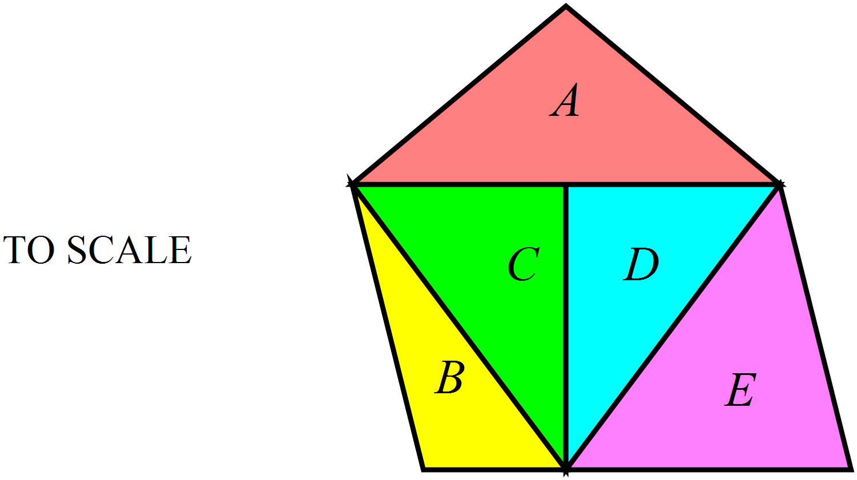Which two triangles are congruent? (Write their letters in the space below.)

……………………………………………………………………….

…………………………………………………………………………
Rotate the triangle through 90° about C in a clockwise direction.
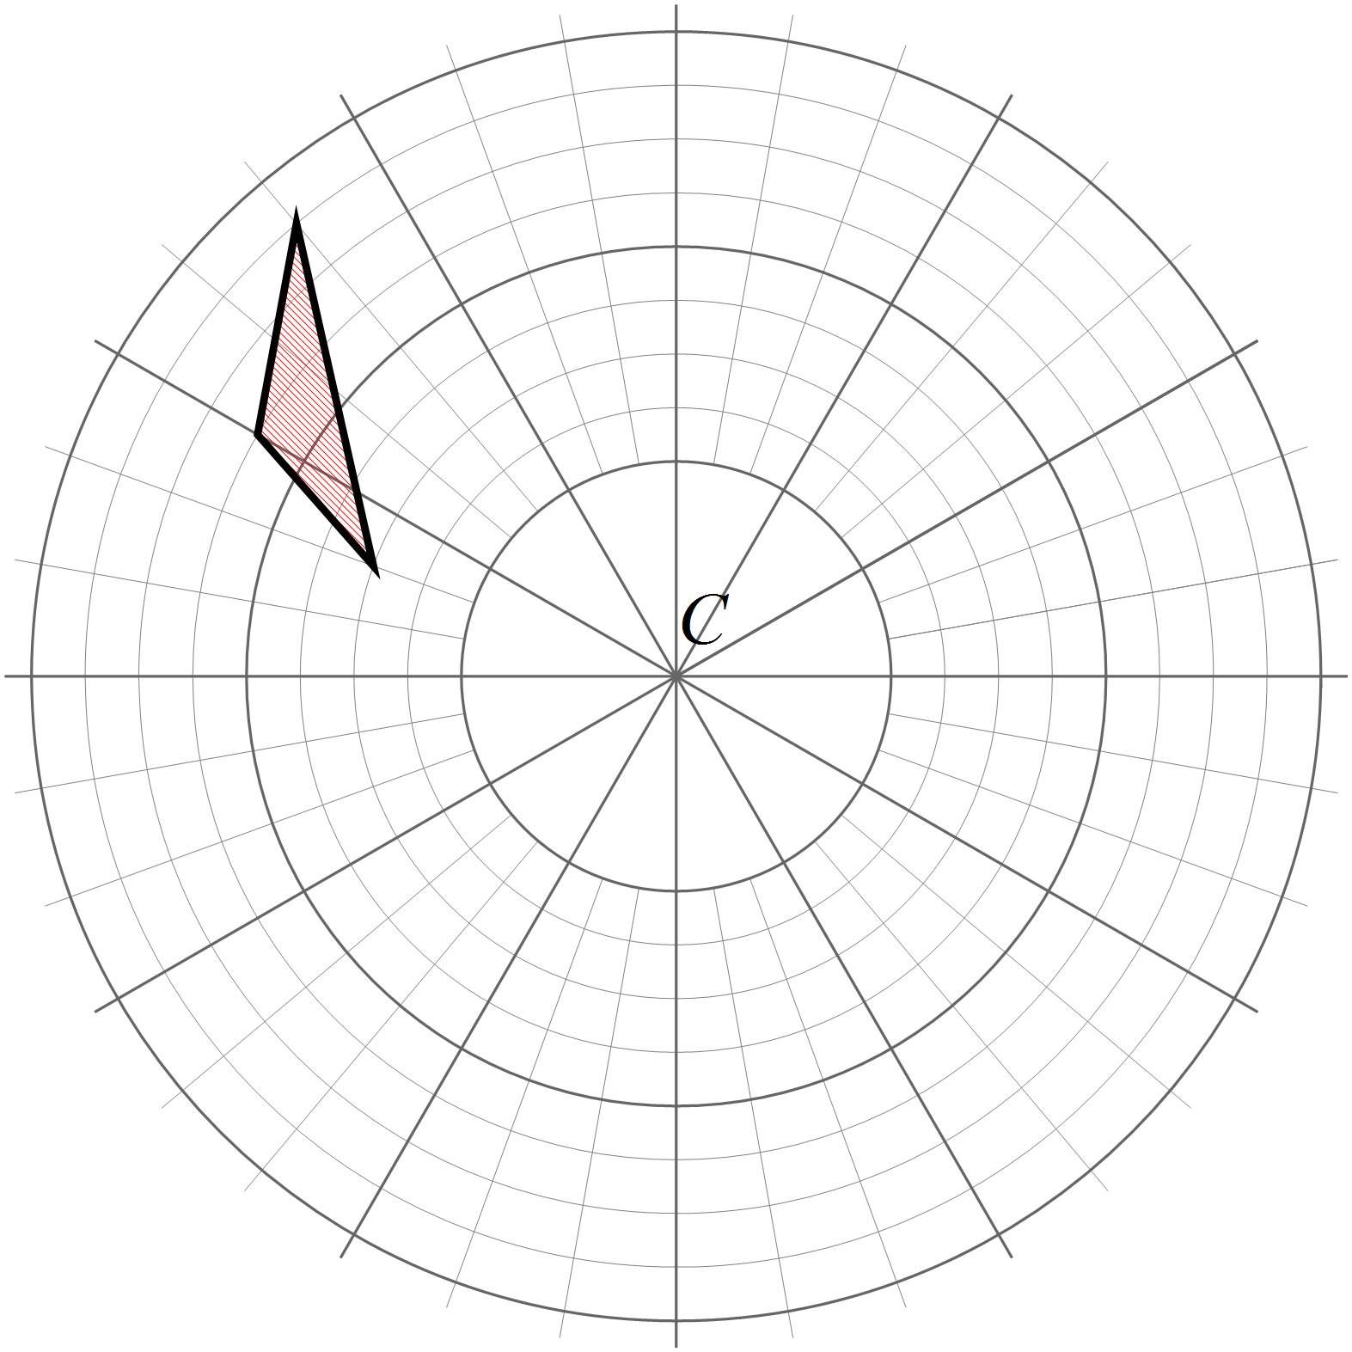

Draw the triangle in its new position.

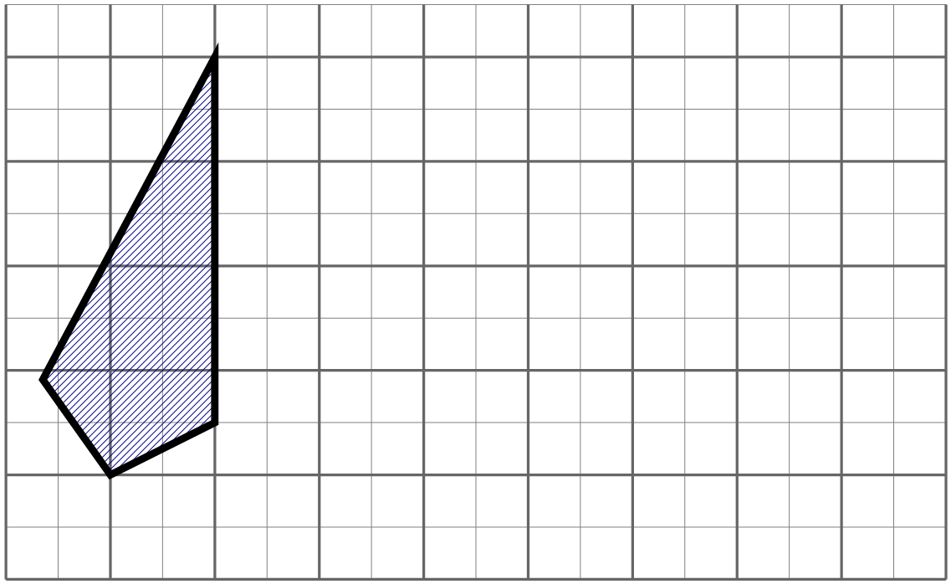Translate the kite 5 cm to the right.

Draw the kite in its new position.

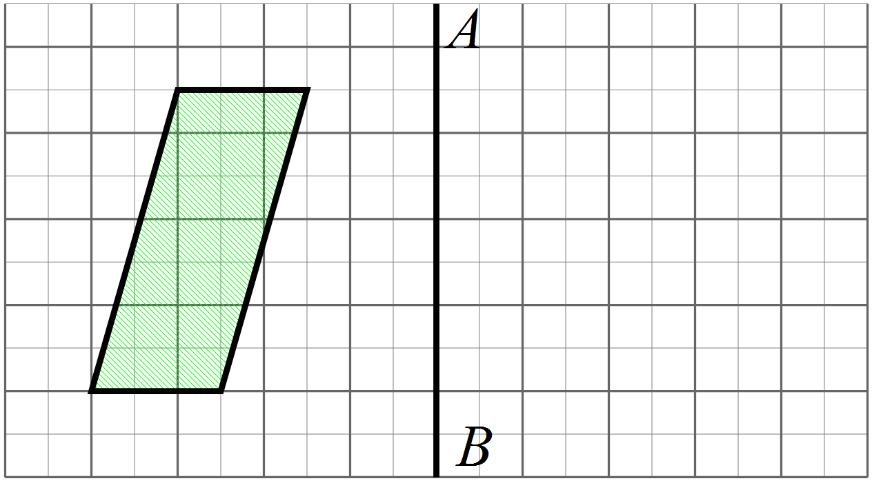Reflect the parallelogram in the line AB.

Draw the parallelogram in its new position.

Which two rectangles are congruent? (Write their letters in the space below.)
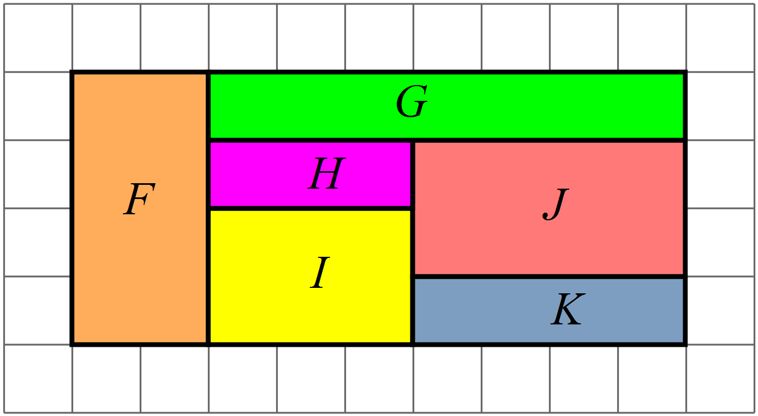

……………………………………………………………………….

…………………………………………………………………………
AAS is an abbreviation for one of the tests for congruent triangles. It says:

Two triangles are congruent if two angles and a side of one triangle are equal to two angles and a corresponding side of the other.

What does the test which is abbreviated as SSS say?

………………………………………………………………………………………………………………………………………………….

…………………………………………………………………………………………………………………………………………………
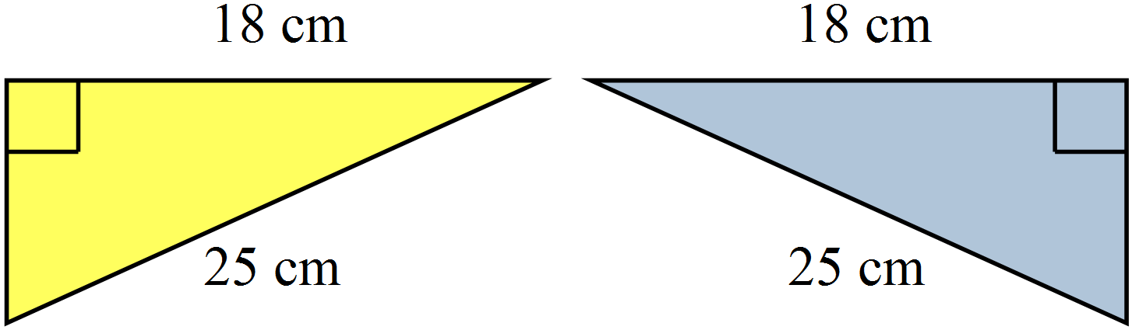Which of the congruence test (AAS, RHS, SAS or SSS) could be used to show congruence of triangles PQR and RSP?

....................................................................
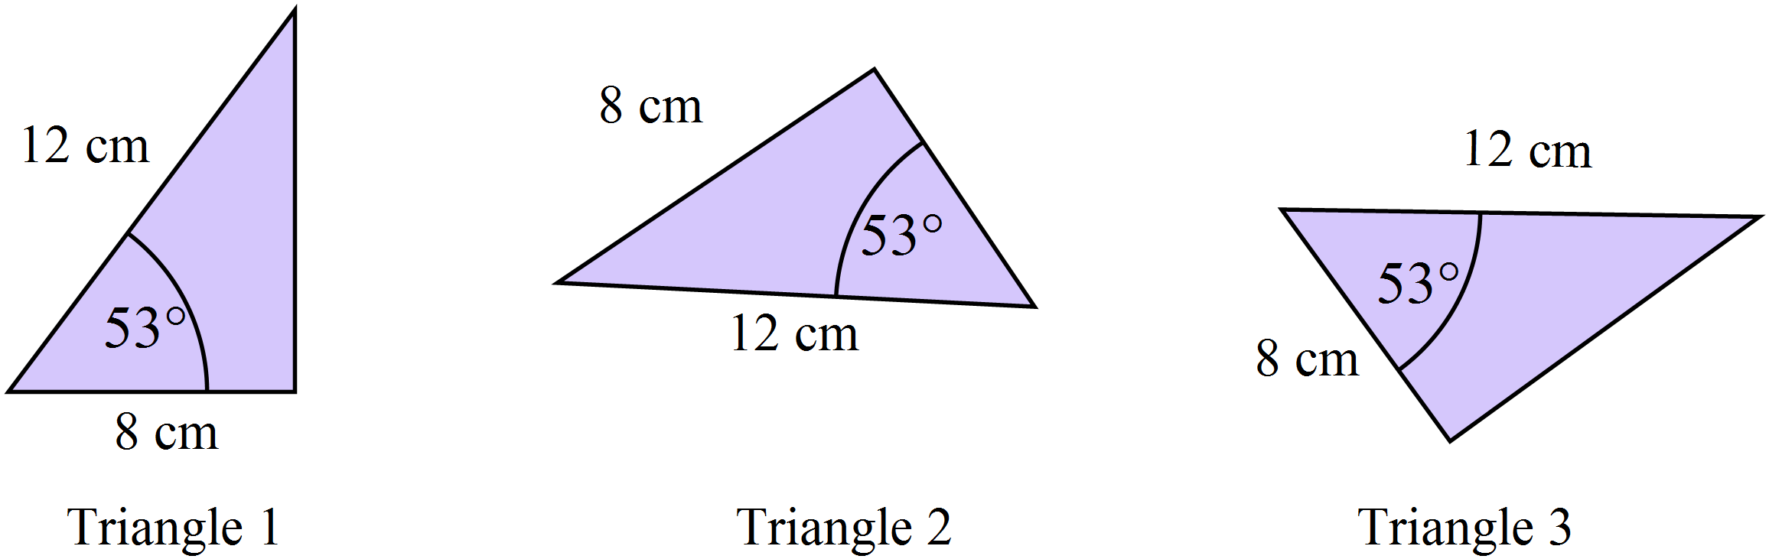Which two triangles below have enough information provided to show they are congruent to one another.
Explain your answer.

……………………………………………………………………………………………….

……………………………………………………………………………………………….
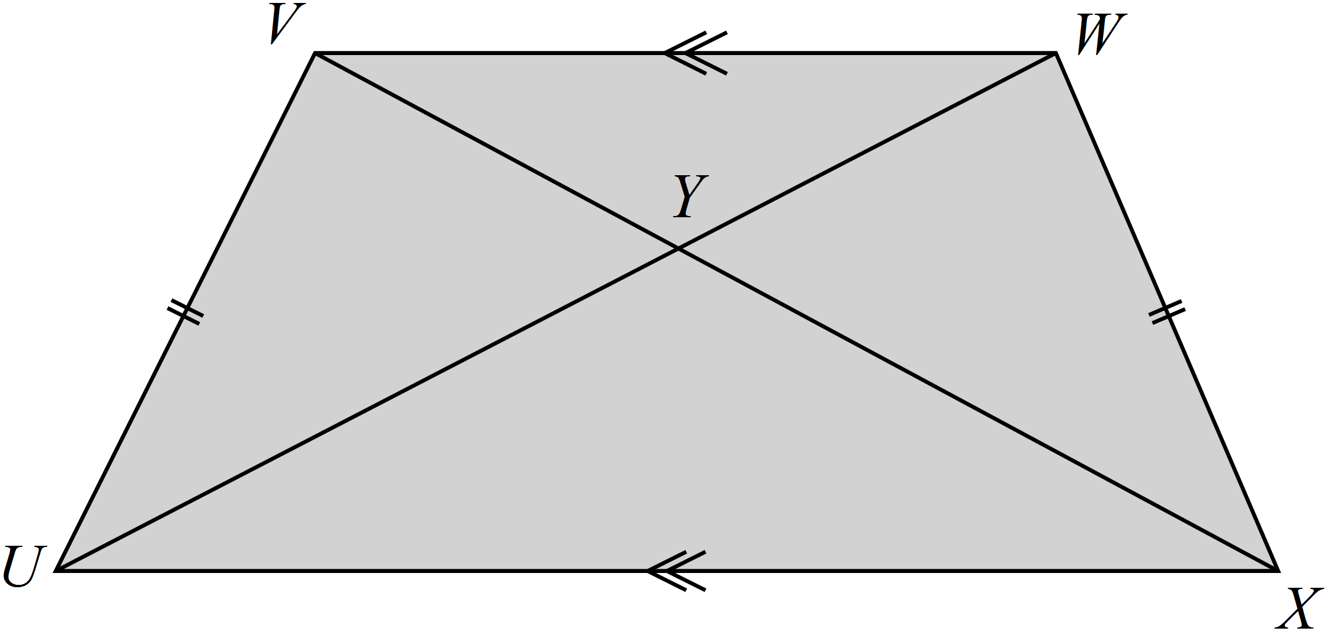UVWX is a trapezium which has a pair of equal sides.
Name a pair of congruent triangles in the diagram.

………………………………………………………………

……………………………………………………………….

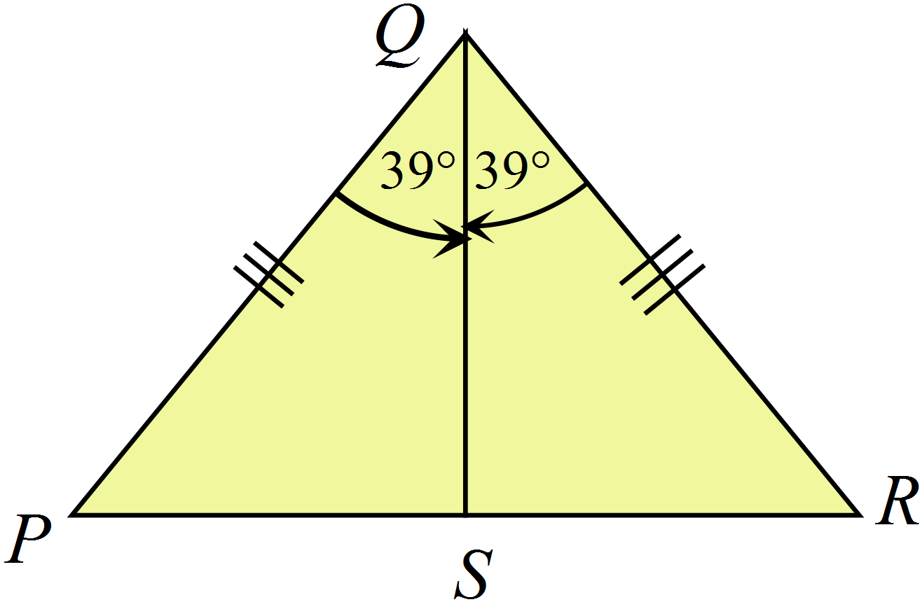Which of the conditions AAS, RHS, SAS or SSS could be used to show congruence of the triangles PQS and RQS? Explain your answer.

……………………………………………………

……………………………………………………
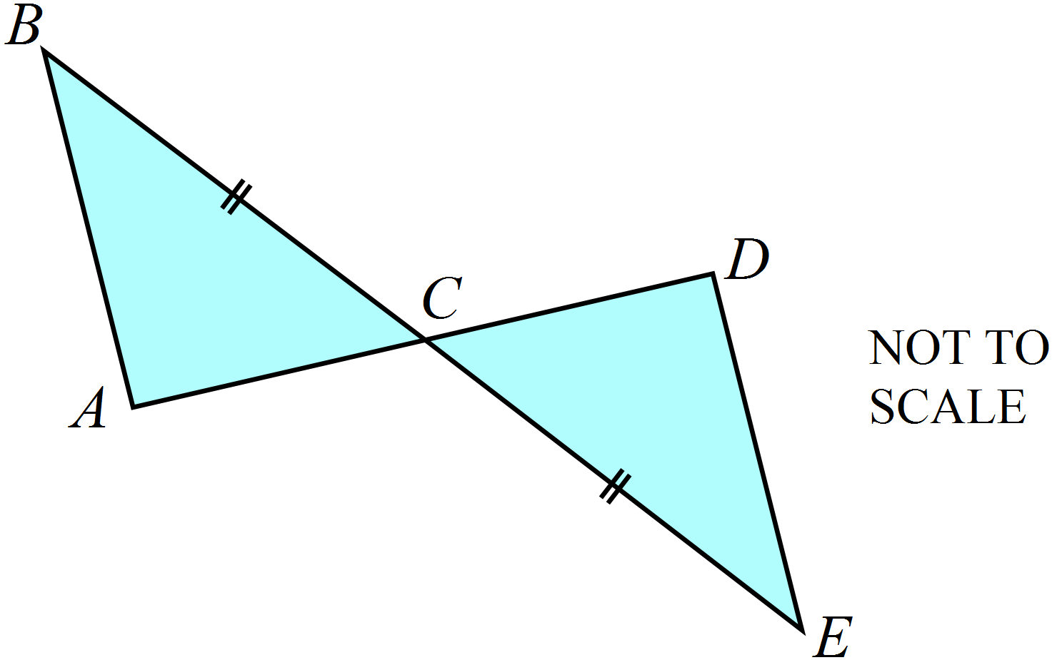In the diagram BE and AD are straight line segments and BC = CE.
What single piece of additional information would be sufficient to use the test SAS to prove that 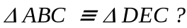

…………………………………………………

…………………………………………………

…………………………………………………
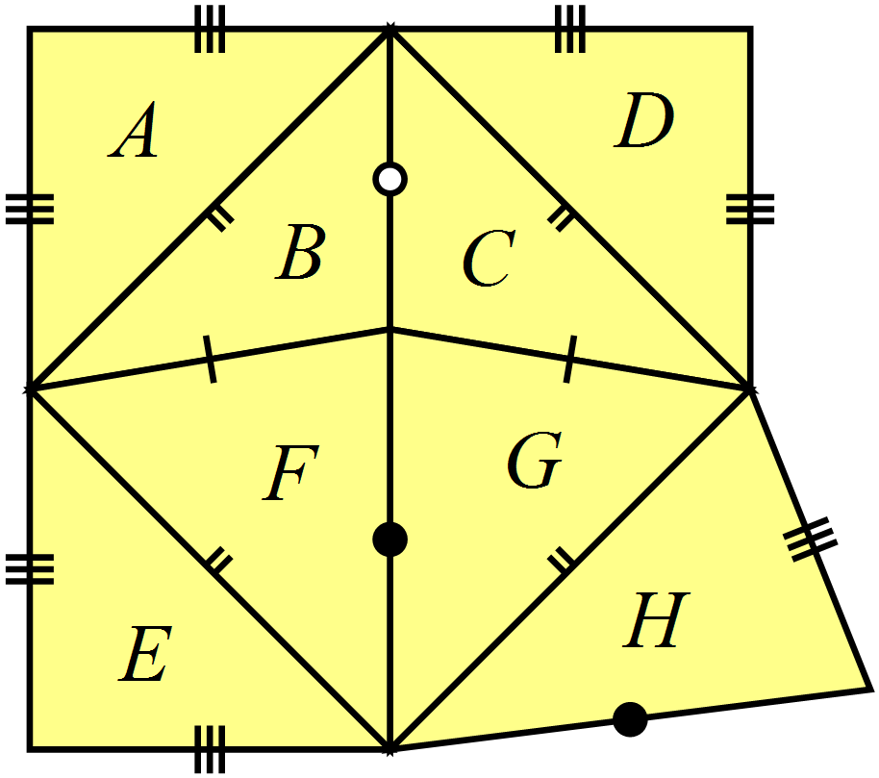Name two triangles which are congruent to triangle A. Explain why.

……………………………………………………………………..

……………………………………………………………………..
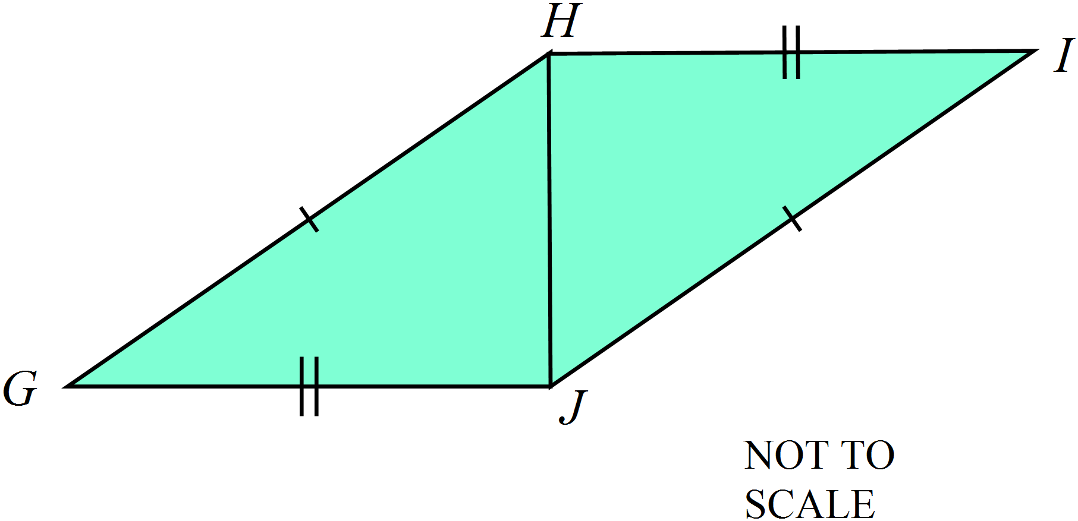Complete the proof below (including the congruence test used) to show that 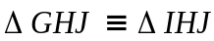
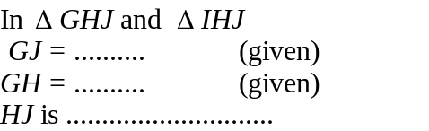

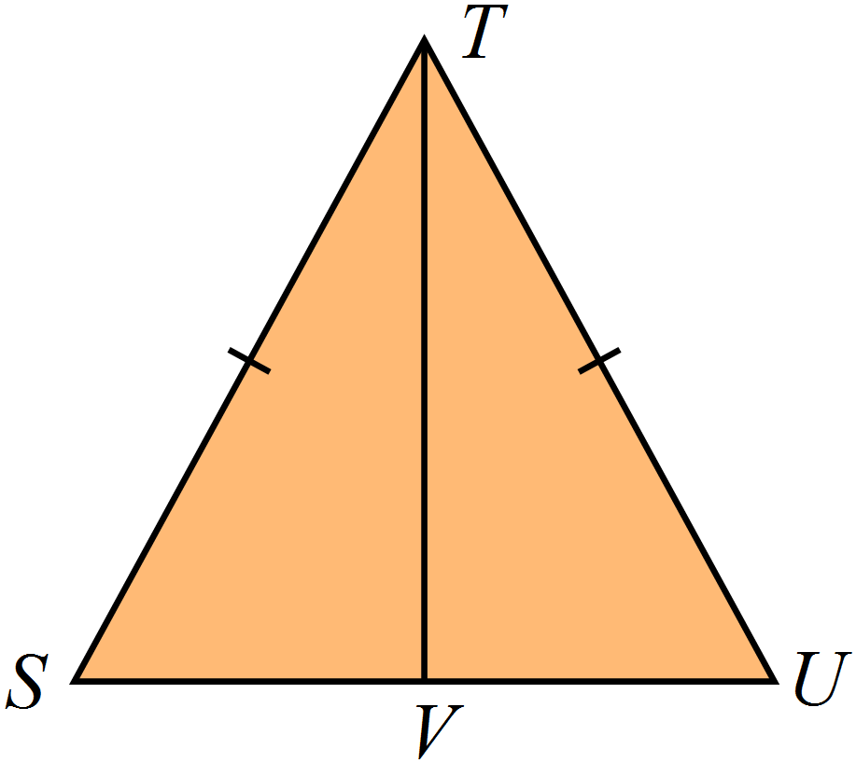Complete the reasons in the congruence proof below:

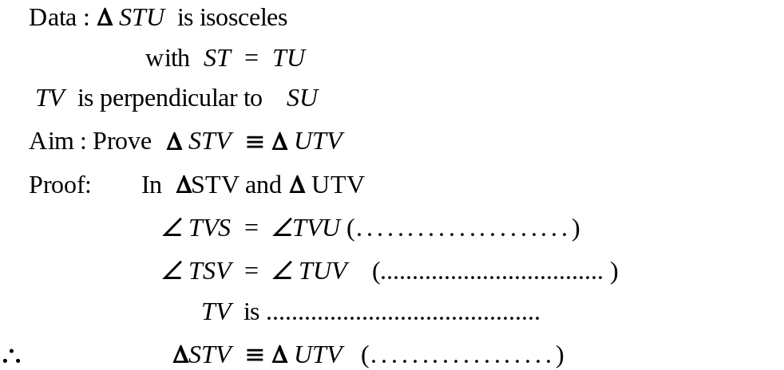
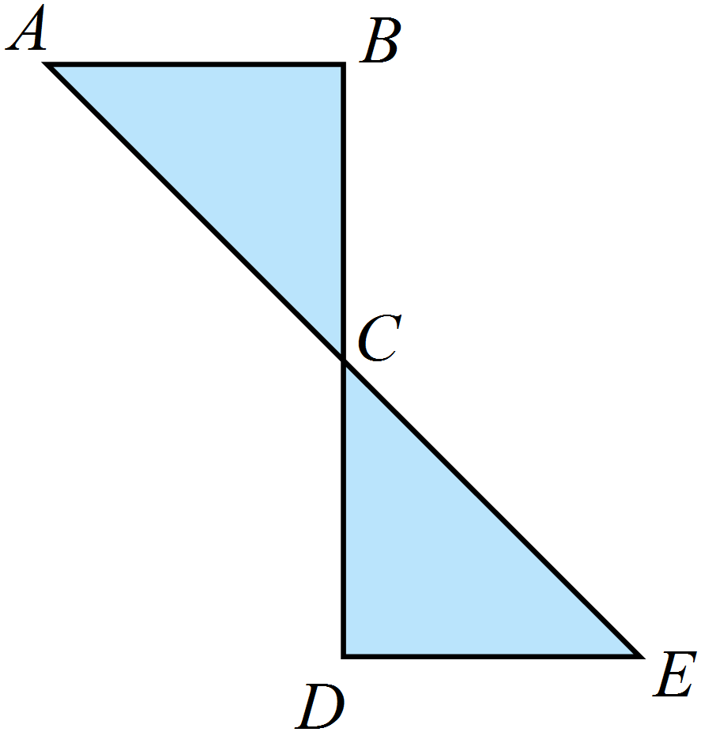Complete the congruence proof below.

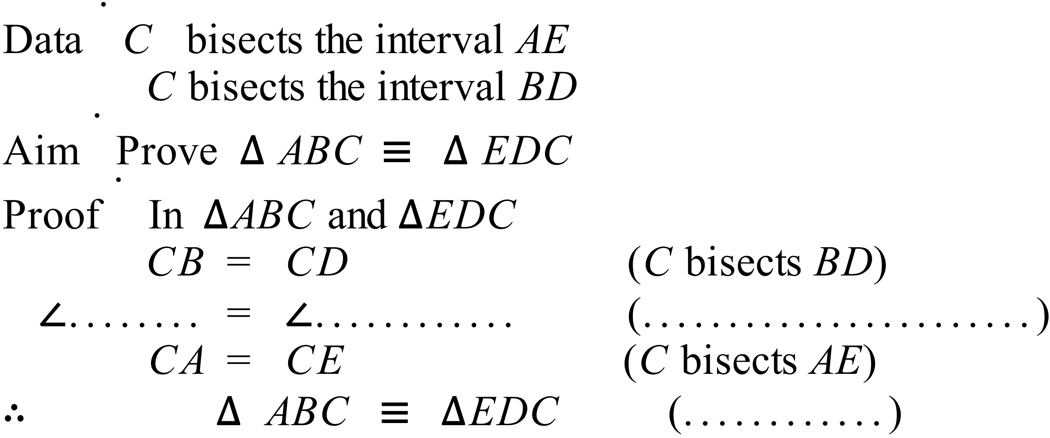

Year |  | Congruence | Calculator Allowed
 |  | Congruence | Name_________________
Section 2 Multiple Choice Section
Mark all your answers on the accompanying multiple choice answer sheet, not on this test paper. You may do any working out on this test paper. Calculators are allowed for this section.

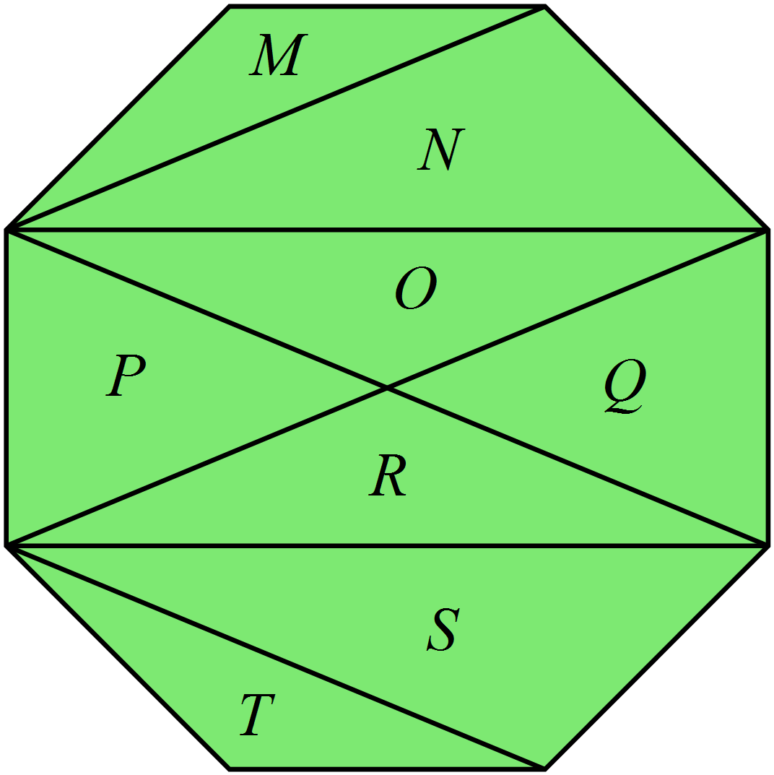The regular octagon has a number of diagonals drawn.

Which of these pairs of triangles are congruent?

A. M and N. B. M and O.

C. N and R. D. N and S.

These two triangles are congruent.

Which transformation could move the first triangle to the second?

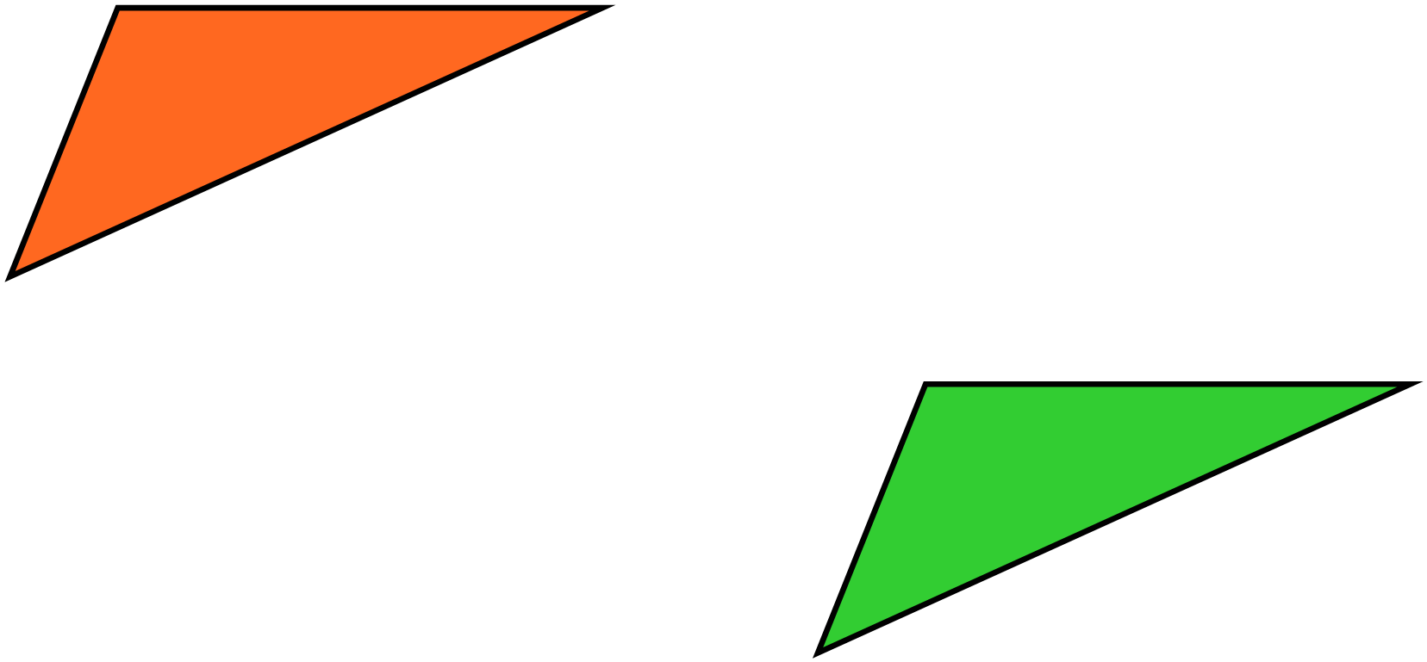A. an enlargement.

B. a reflection.

C. a rotation.

D. a translation.

This figure seven is transformed to a congruent figure by a reflection.
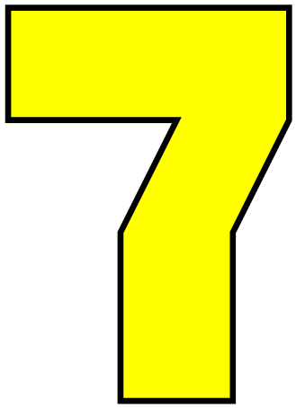

Which figure is the possible result?
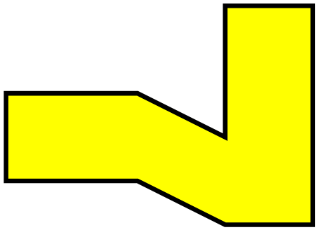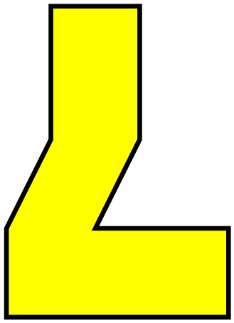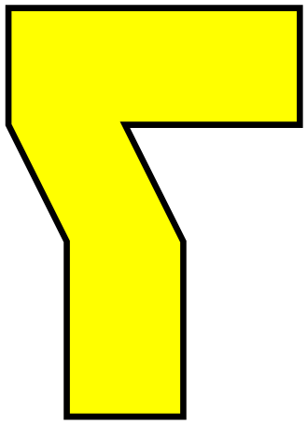
A. B. C. D.

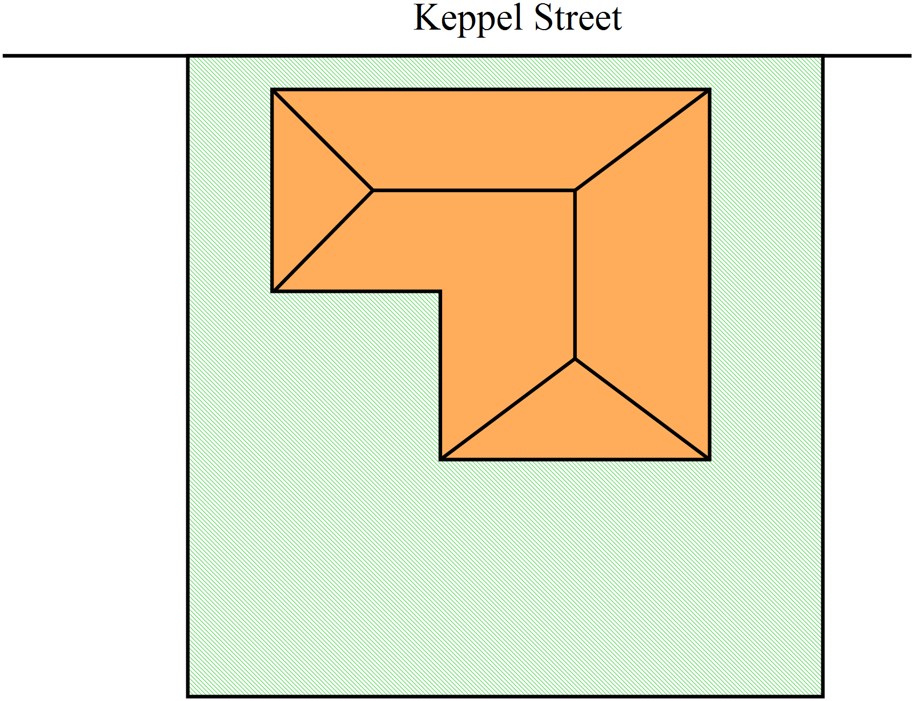Jack draws up a plan of a house on a block of land.

He decides to change the plan by rotating the house through 180º on the block of land.
Which could be his new plan?

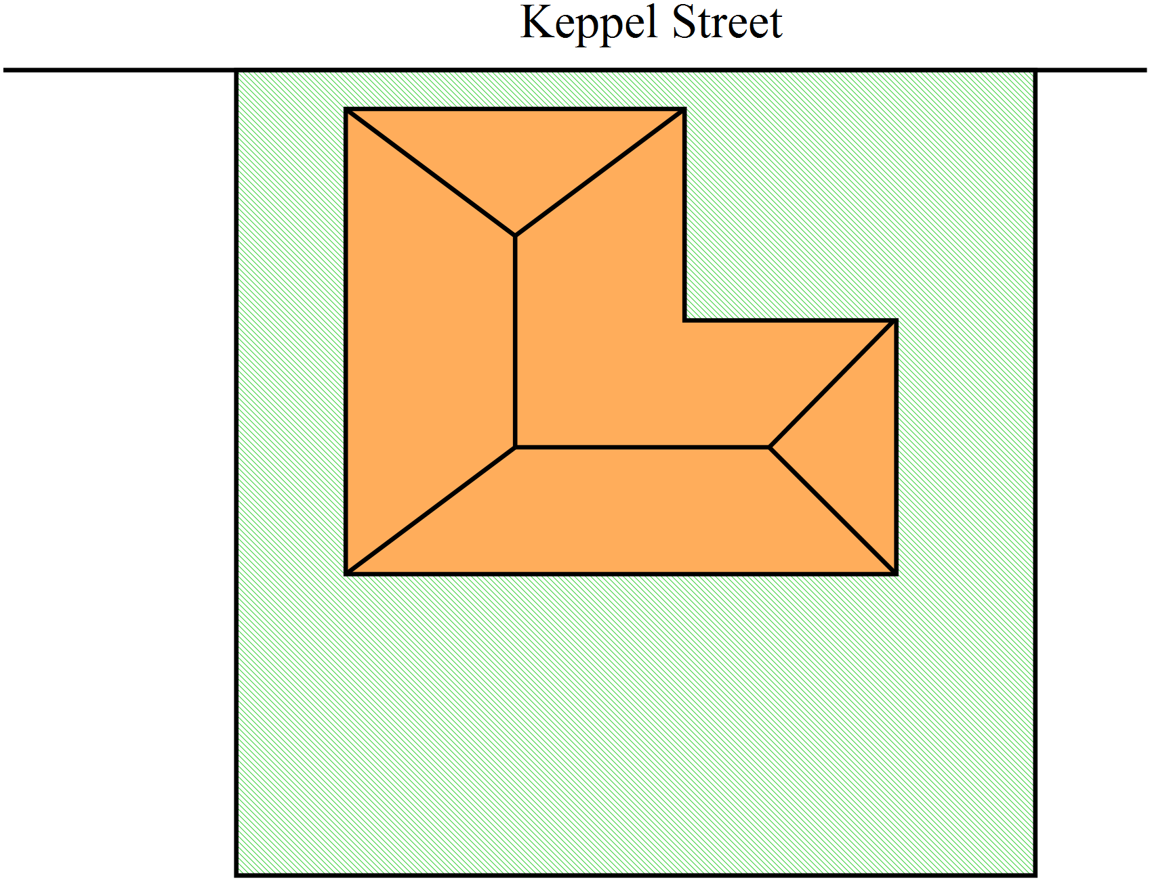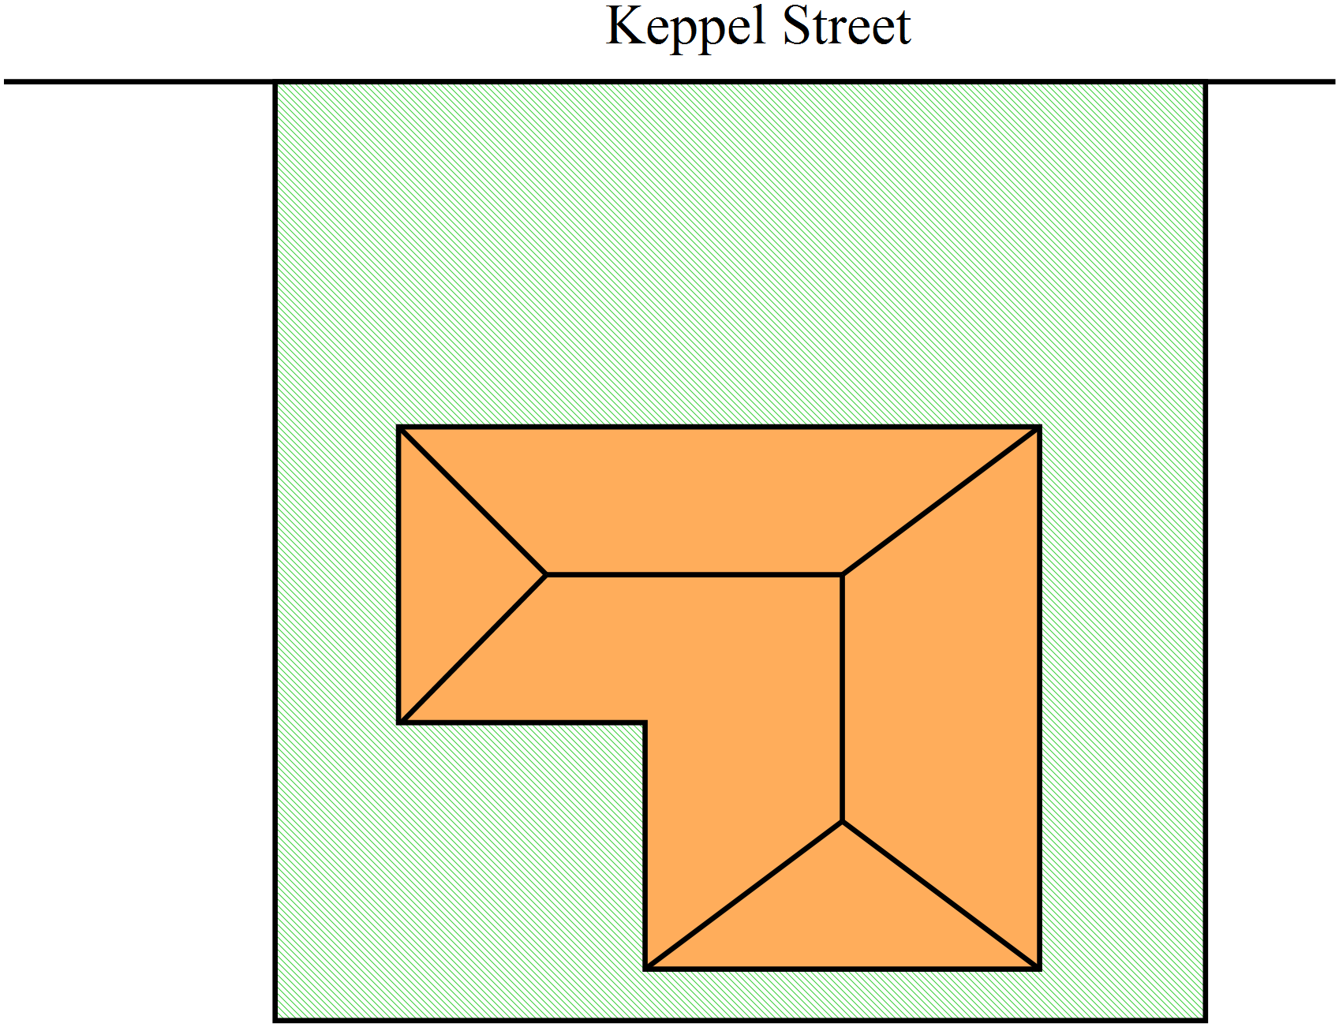 A. B.

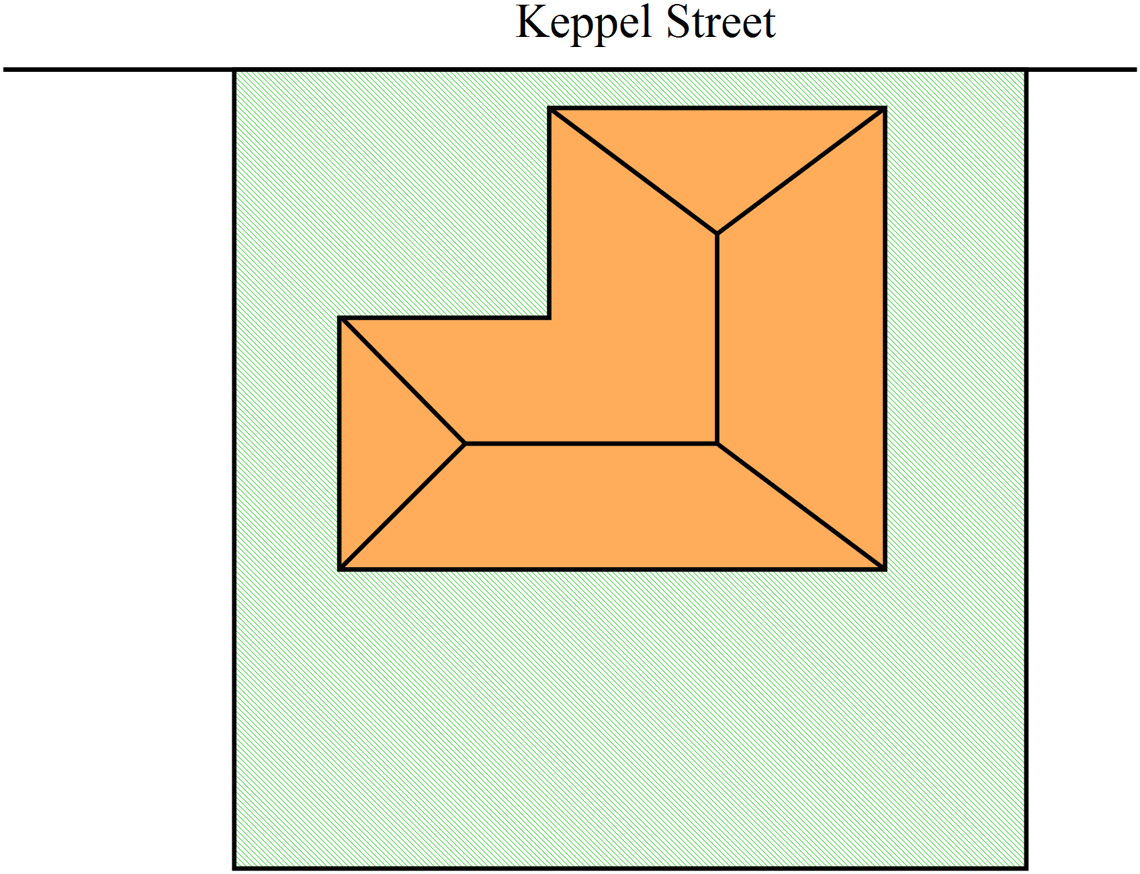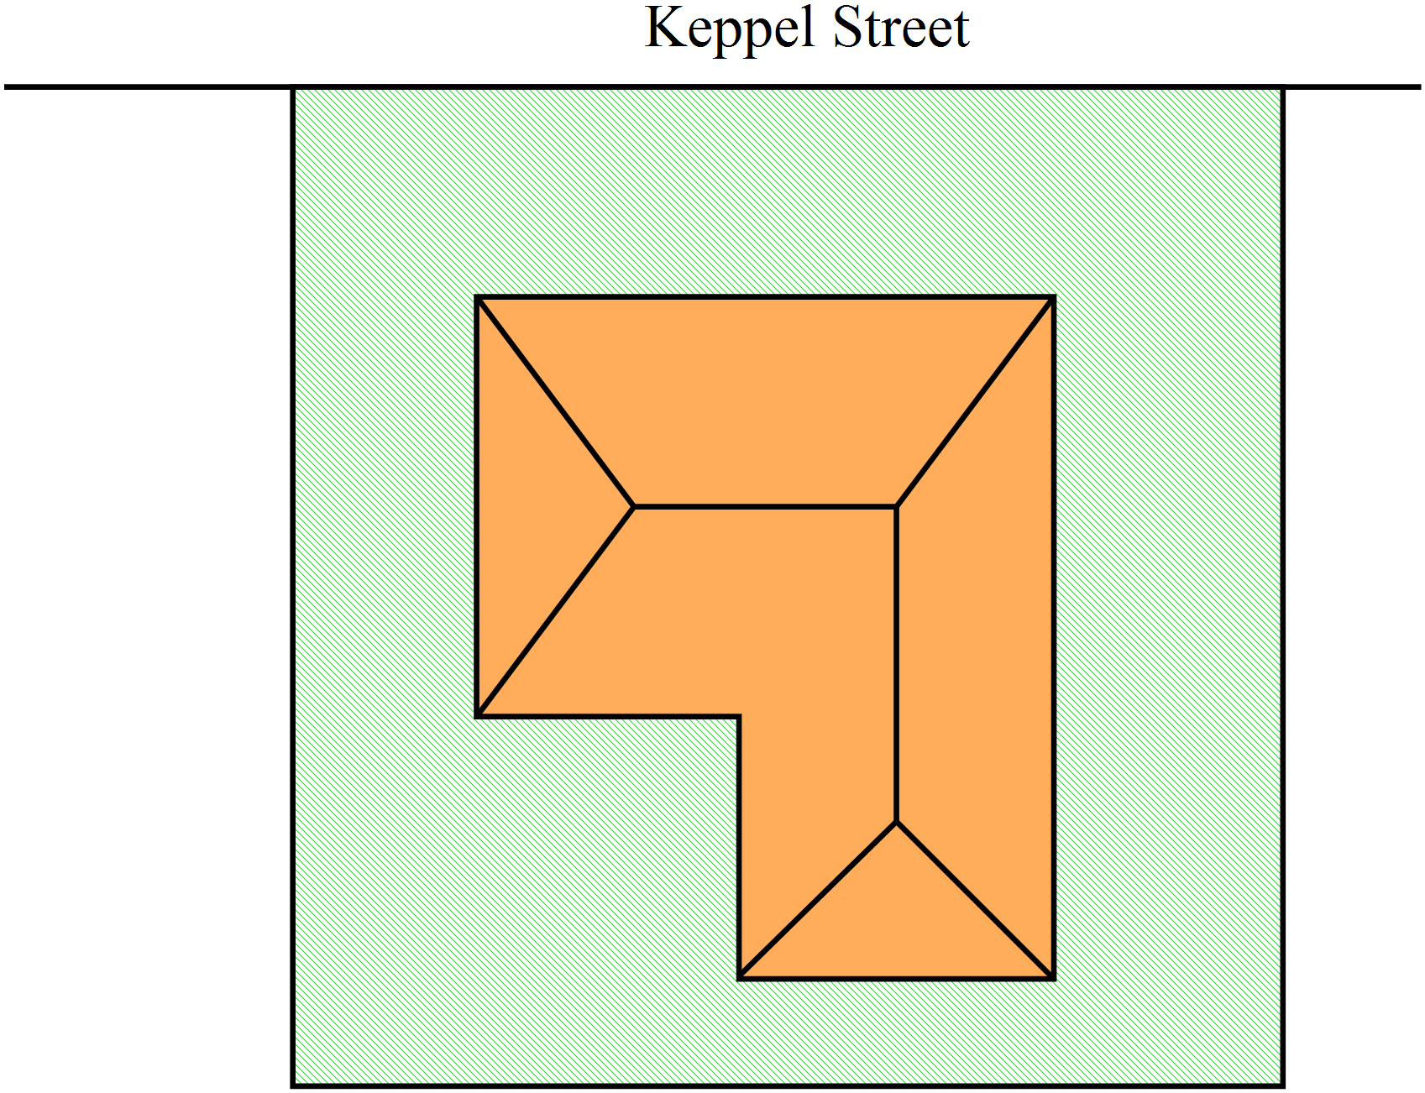
C. D.

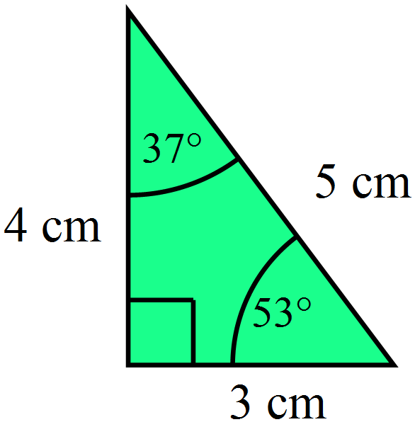Triangle A is a right angled triangle with the measurements shown at right.

Which of these triangles must be congruent to Triangle A?

The diagrams are not to scale.

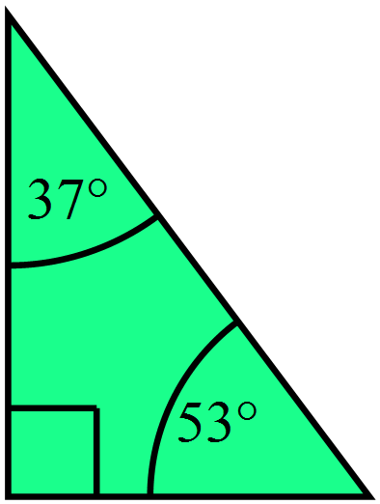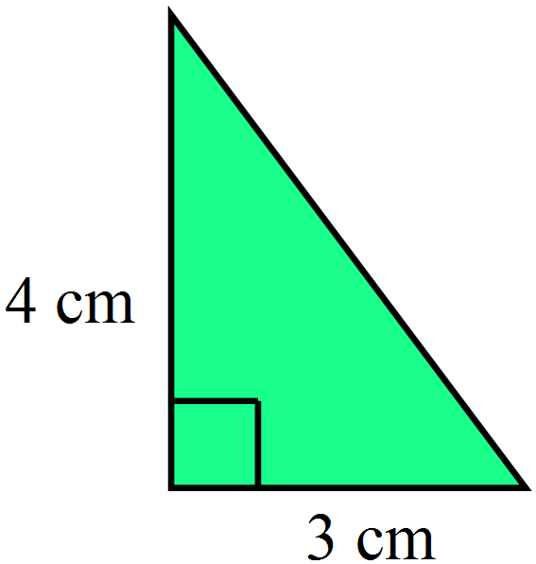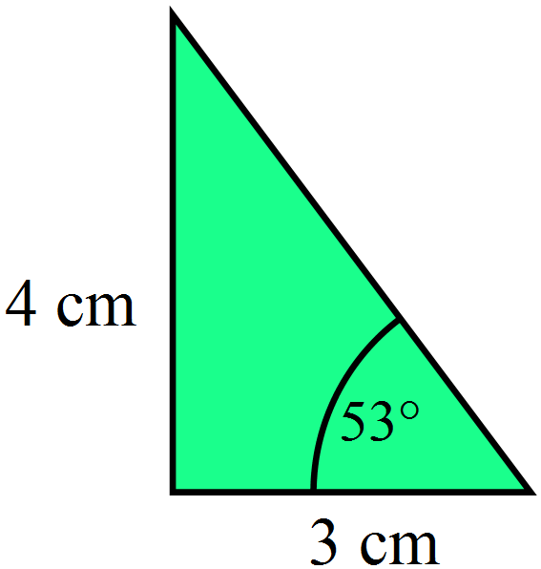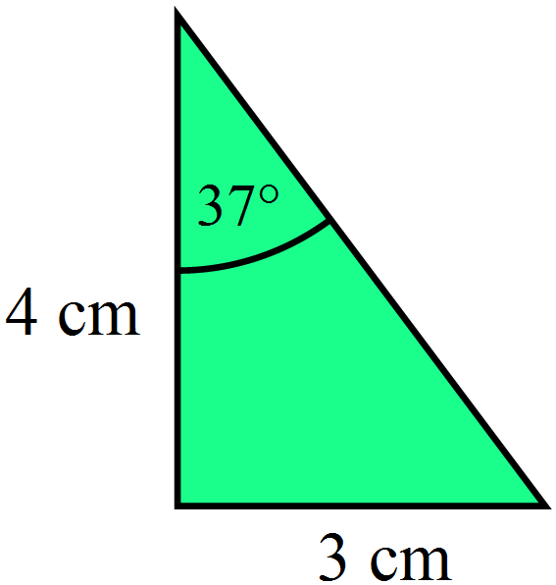 A. B. C. D.

Which of these is not a test for a pair of congruent triangles?

A. Three pairs of corresponding angles are equal.

B. Three pairs of corresponding sides are equal.

C. Two pairs of corresponding sides and a pair of included angles are equal.

D. Two pairs of corresponding angles and a pair of corresponding sides are equal.

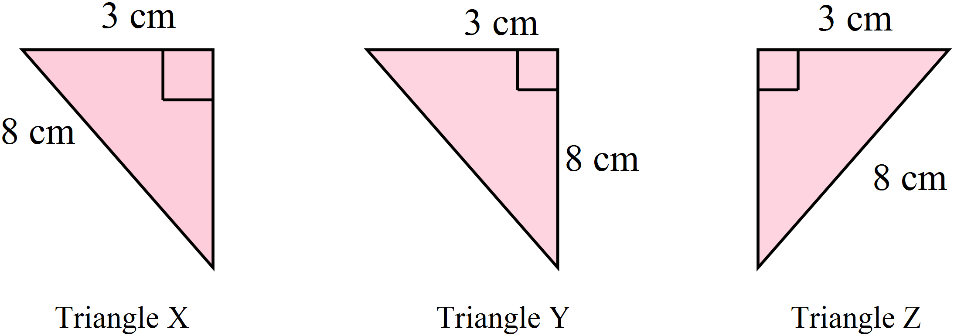Which triangles are congruent?

A. All three triangles.

B. Triangles X and Y.

C. Triangles X and Z.

D. Triangles Y and Z.

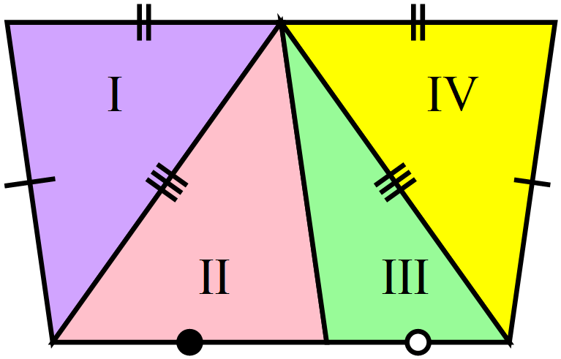Which statement is true?

A. Triangle I is congruent to triangle II only.

B. Triangle I is congruent to triangle IV only.

C. Triangle I is congruent to triangle IV and triangle II is congruent to triangle III.

D. Triangle I is congruent to triangle II and triangle III is congruent to triangle IV.

Which of the congruence tests is sufficient to prove that 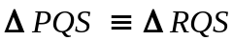 ?

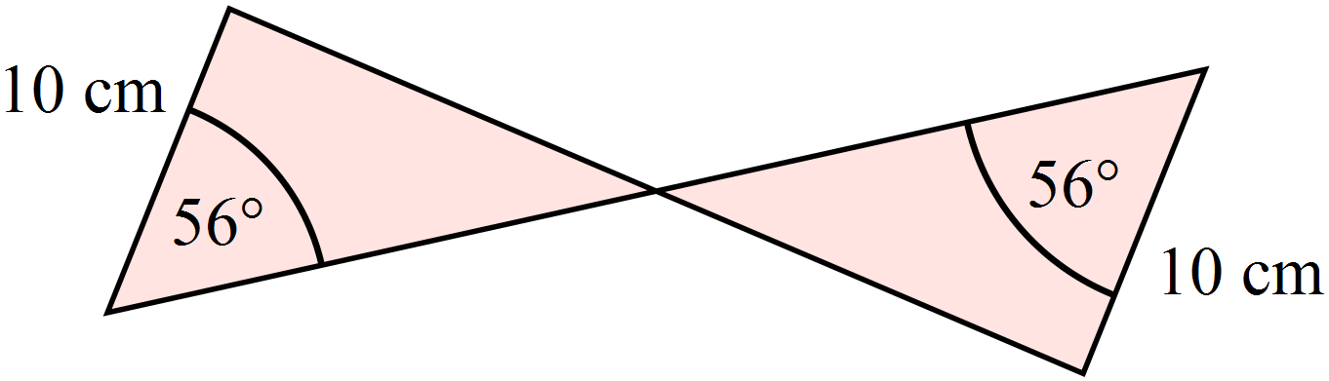

A. (AAS) B. (RHS) C. (SAS) D. (SSS)

Which triangles are congruent ?
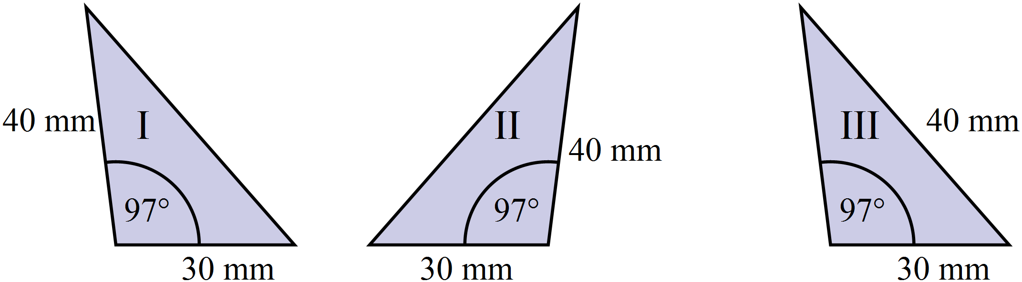

A. I, II and III. B. I and III only.
C. II and III only. D. I and II only.
In which triangle is there enough information to prove that 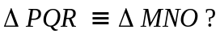
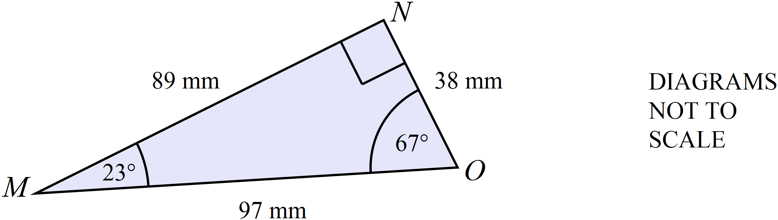

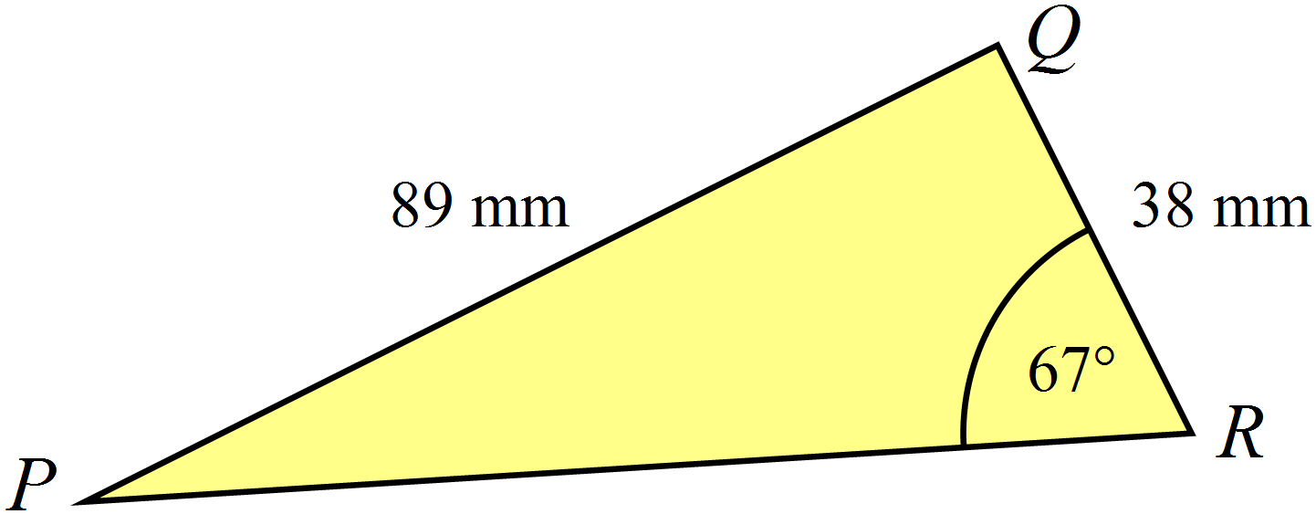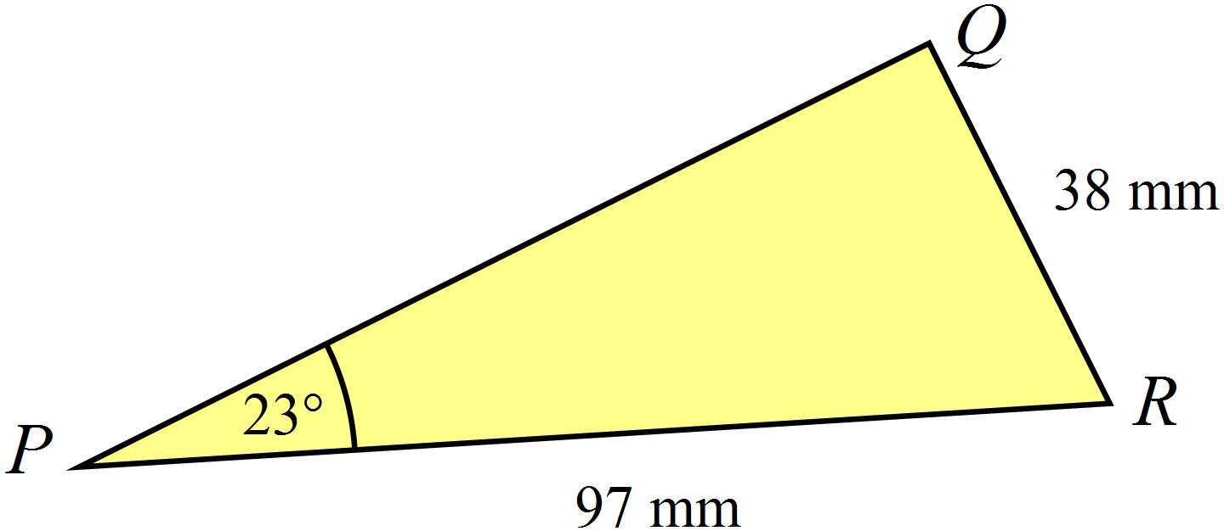
A. B.

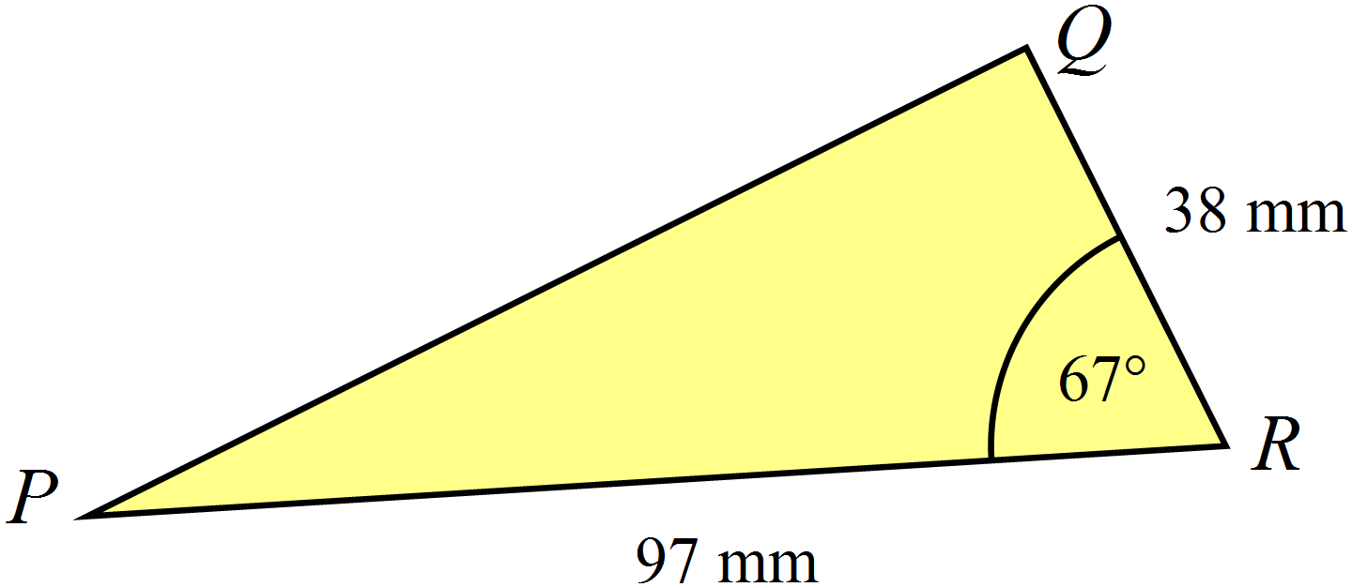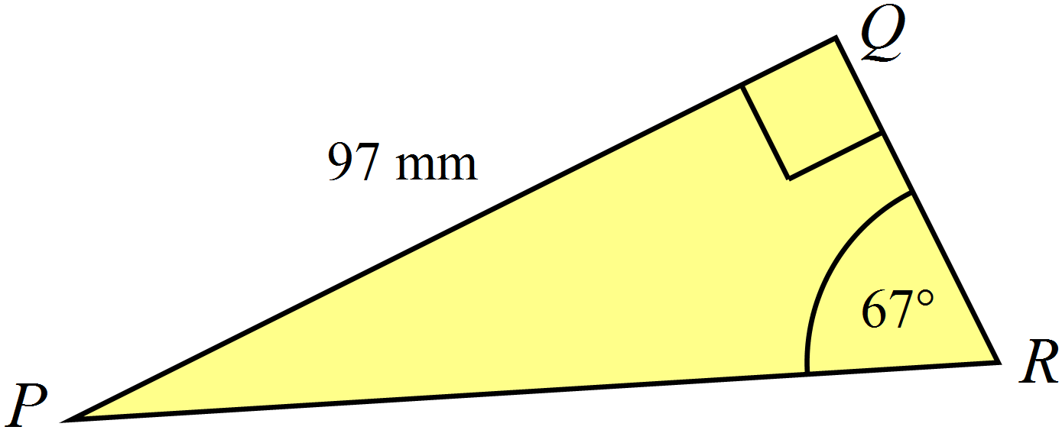
C. D.

Which of the congruence tests is sufficient to prove that 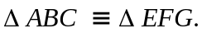 ?
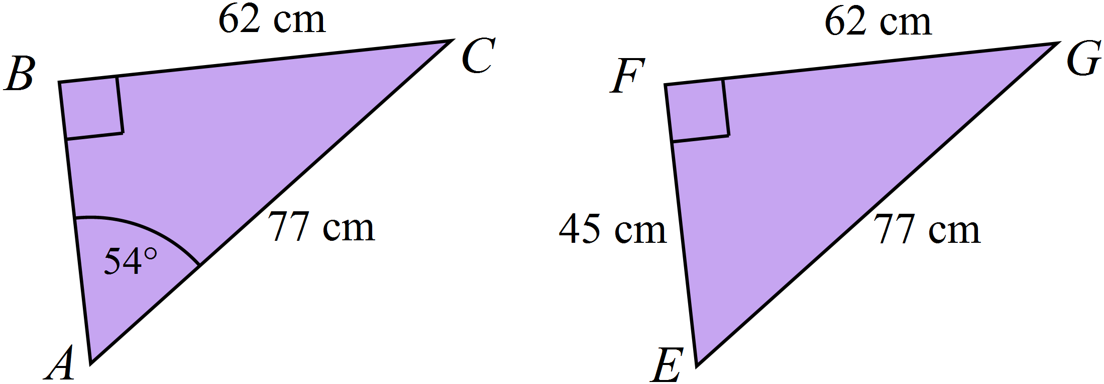

A. AAS B. RHS C. SAS D. SSS
The diagonals of the rhombus UVWX are drawn, intersecting at Y.
We can assume a rhombus to be a quadrilateral with all sides equal.
Assume no other properties of the rhombus.
Which of the congruence tests is sufficient to prove that 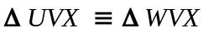 ?
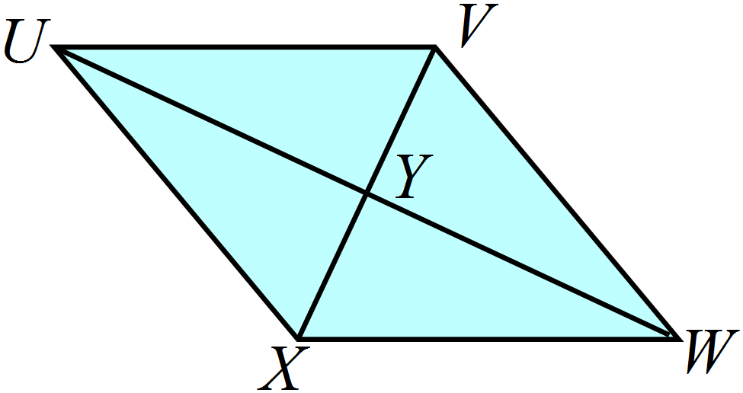

A. (AAS) B. (RHS) C. (SAS) D. (SSS)
Kate has been drawing a tiling pattern on isometric grid paper.
She has used several different sets of congruent triangles.
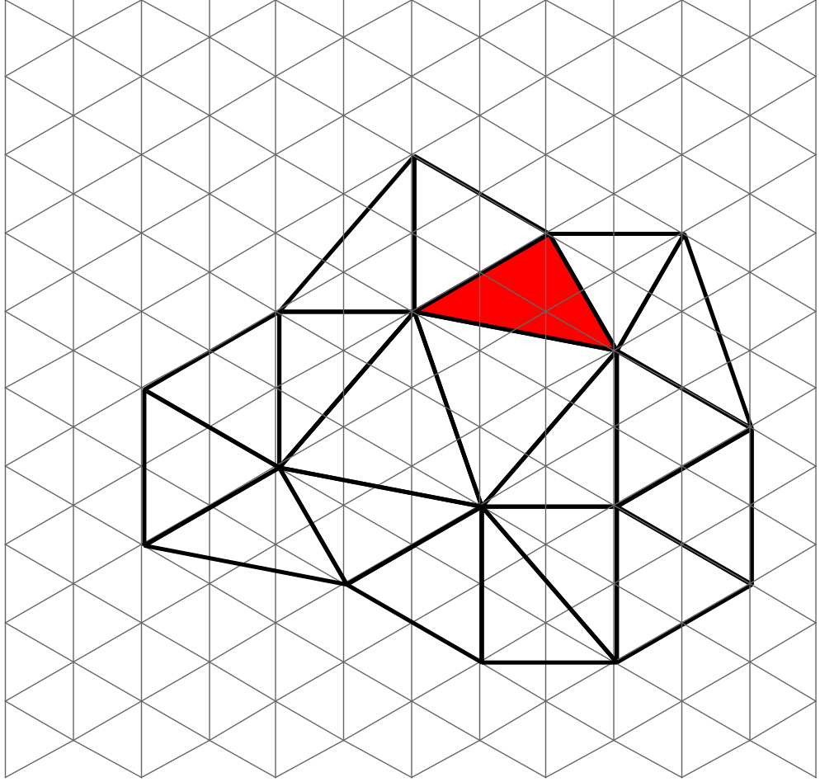

How many triangles has she drawn which are congruent to the shaded triangle? (including the shaded triangle).

A. 2 B. 7 C. 9 D. 19.

Kyle is writing a proof that 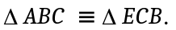
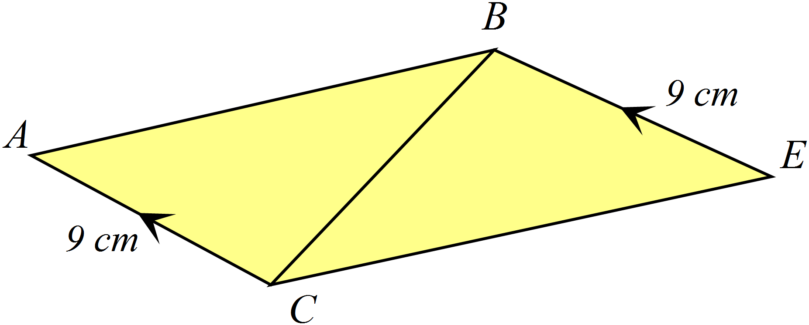He has left out a reason in the spot indicated by *******
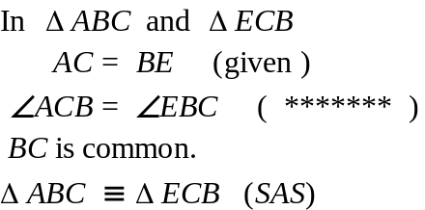
Which reason should go in the spot?

A. Alternate angles on parallel lines.

B. Cointerior angles on parallel lines.

C. Equal supplementary angles.

D. Vertically opposite angles.

Year | Congruence | Calculator Allowed
Year | Congruence | Name___________________
Section 3 Longer Answer Section
Answers should be supported by relevant mathematical reasoning and/or calculations.
Write all working and answers in the spaces provided on this test paper.

 |  | Marks
 | (a) Reflect the figure ABCDE in the line PQ and draw the image A’B’C’D’E’.  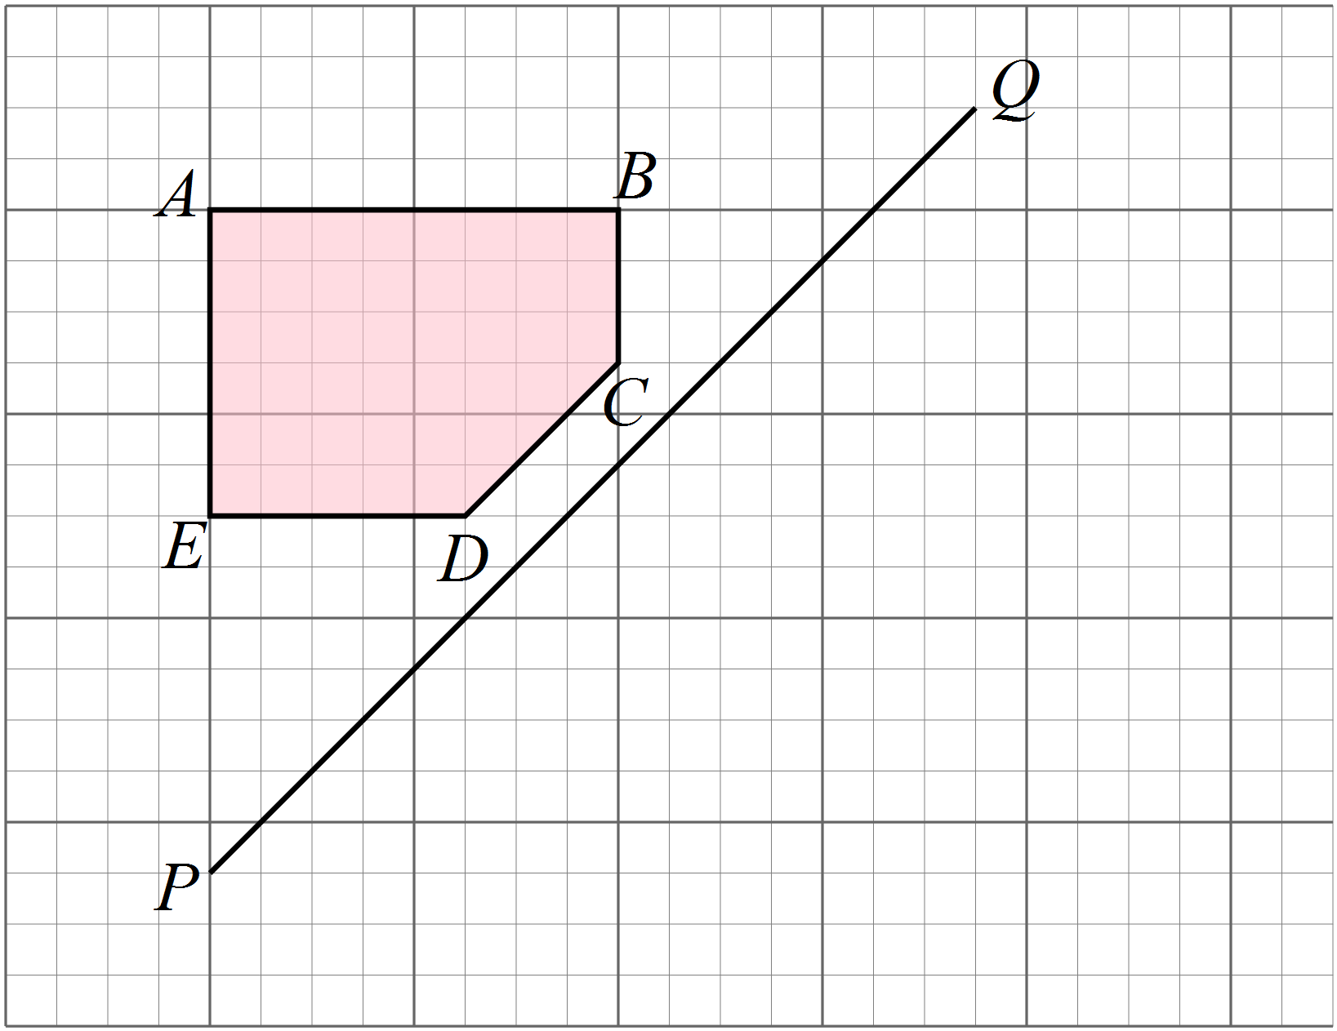 | 2
 | (b) Measure the distances DC and D’C’.  What can you say about the two distances?  ………………………………………………………………………………………………………………………………………………….  …………………………………………………………………………………………………………………………………………………. | 1
 | (c) What word describes the two figures ABCDE and A’B’C’D’E’  …………………………………………………………………………………………………………………………………………………. | 1
 | (a) A pattern of congruent triangles and kites has been started.  Continue the pattern by drawing at least five more shapes.  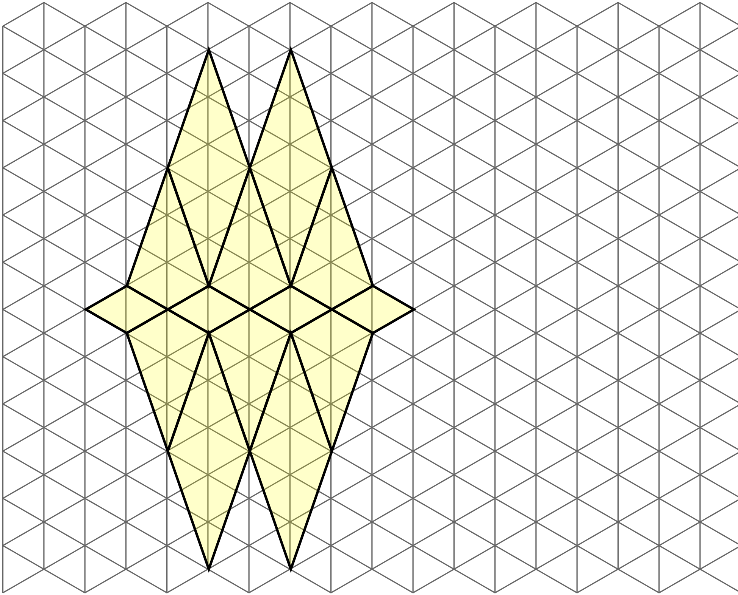 | 2
3. | (a) A triangle ABC has sides whose lengths are identical to the three intervals below.  Use instruments to accurately draw a triangle congruent to ABC. | 2
 | (b) A triangle PQR has two sides which measure 6 cm and 8 cm, with an angle of 30º between them.  Use instruments to accurately draw a triangle congruent to PQR. | 2
4. | (a) Prove that 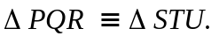  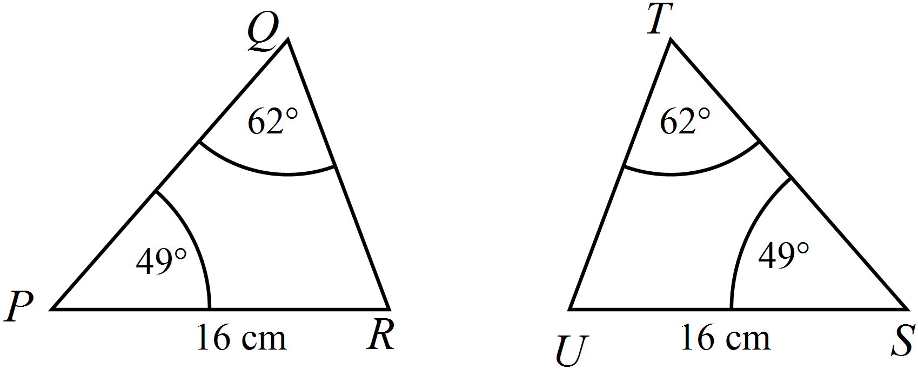  ………………………………………………………………………………………………………………………………………………….  …………………………………………………………………………………………………………………………………………………  …………………………………………………………………………………………………………………………………………………  ………………………………………………………………………………………………………………………………………………….  …………………………………………………………………………………………………………………………………………………  ………………………………………………………………………………………………………………………………………………… | 2
 | (b) Prove that 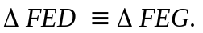  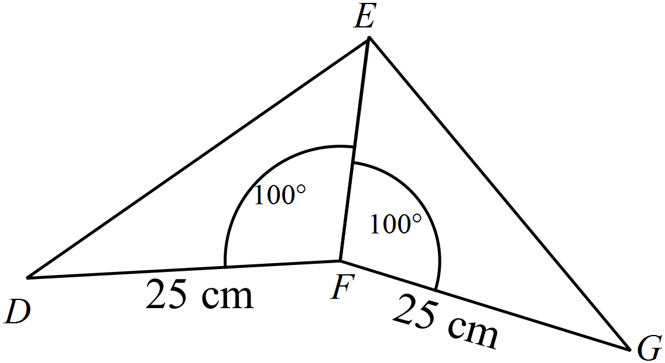  ………………………………………………………………………………………………………………………………………………….  …………………………………………………………………………………………………………………………………………………  …………………………………………………………………………………………………………………………………………………  ………………………………………………………………………………………………………………………………………………….  …………………………………………………………………………………………………………………………………………………  ………………………………………………………………………………………………………………………………………………… | 2
 | (c) In the quadrilateral VWXY, VW || YX and VY || WX.  Prove that 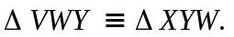  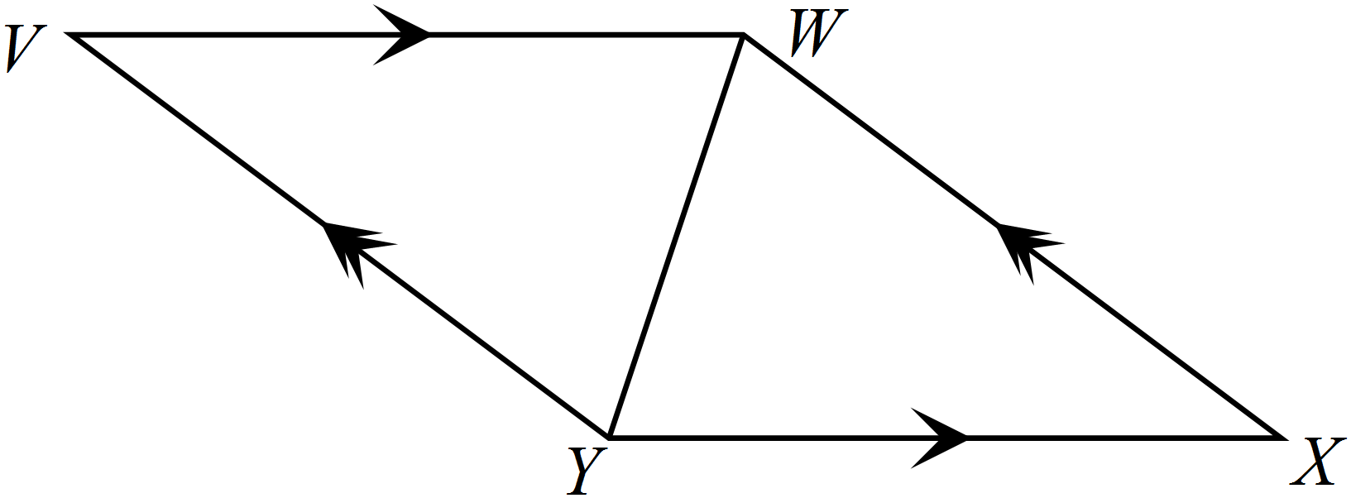  ………………………………………………………………………………………………………………………………………………….  …………………………………………………………………………………………………………………………………………………  …………………………………………………………………………………………………………………………………………………  ………………………………………………………………………………………………………………………………………………….  …………………………………………………………………………………………………………………………………………………  ………………………………………………………………………………………………………………………………………………… | 2

Multiple Choice Answer Sheet
Name _____________________________________________
Completely fill the response oval representing the most correct answer.

1. A B C D
2. A B C D
3. A B C D
4. A B C D
5. A B C D
6. A B C D
7. A B C D
8. A B C D
9. A B C D
10. A B C D
11. A B C D
12. A B C D
13. A B C D
14. A B C D
15. A B C D

Congruence

ANSWERS
Section 1 ( 1 mark each)
Working and Answers
C and D are congruent.
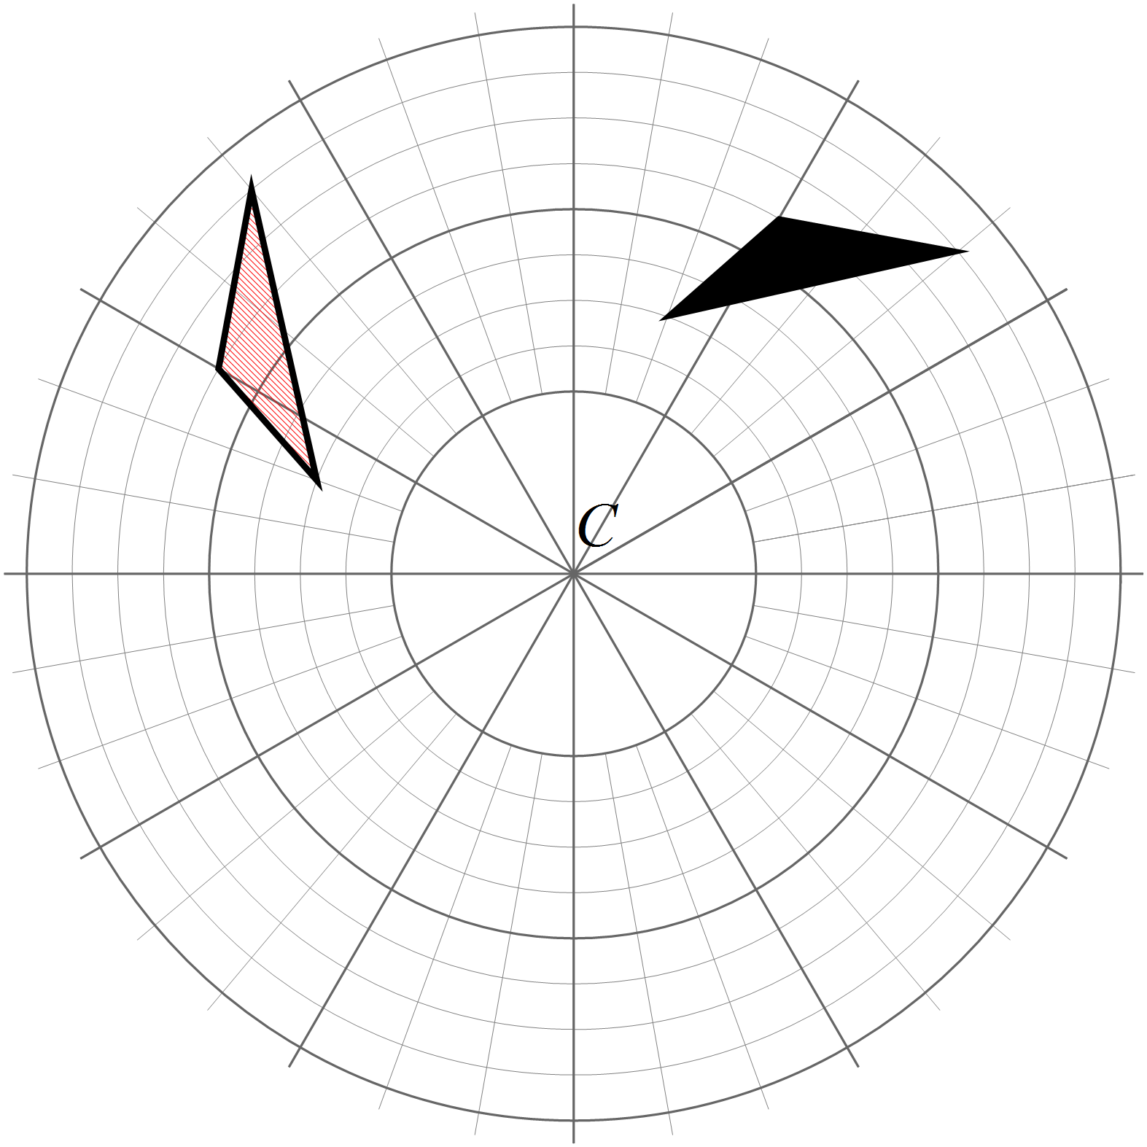

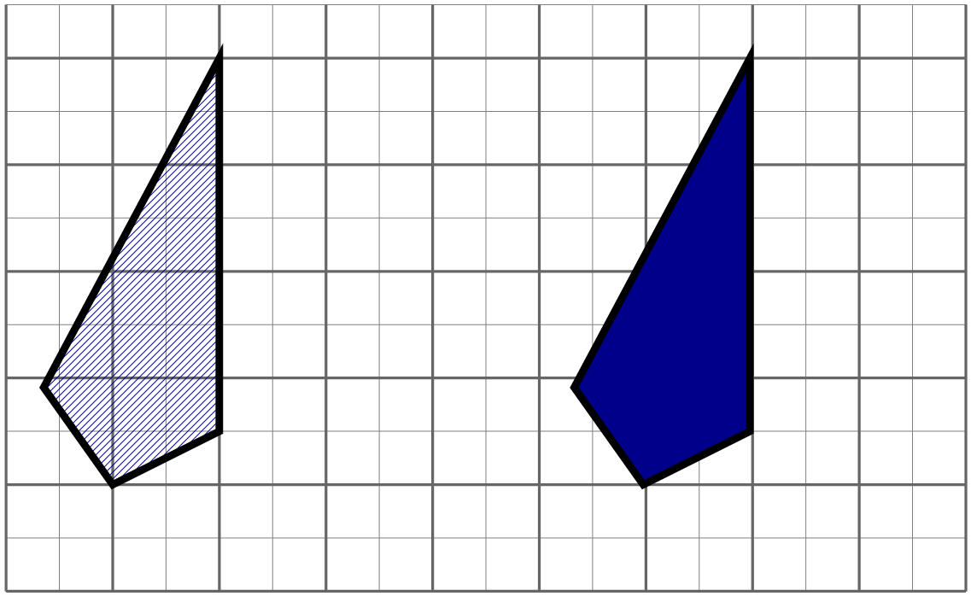

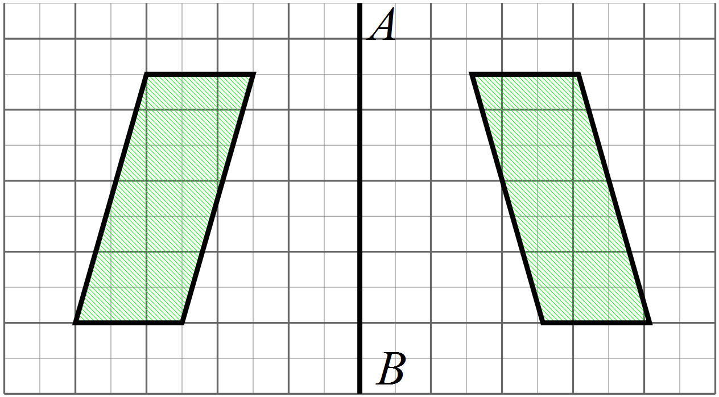

Rectangles F and J. They both measure 4 by 2. One has been rotated 90º.
Two triangles are congruent if the three sides of one triangle are equal to the three corresponding sides of the other.
RHS (Right angle, Hypotenuse and Side.)
Triangle 1 and Triangle 3 have enough information to use the SAS test to prove congruence.
Three Possible Pairs of triangles (Only need one of these):
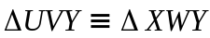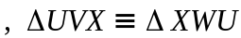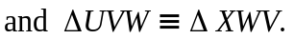
SAS, using the common side and the data given.
AC = CD (or C bisects AD)
This gives sufficient data to prove congruence using SAS using the vertically opposite angles.
Triangles D and E as they all have the same side lengths SSS
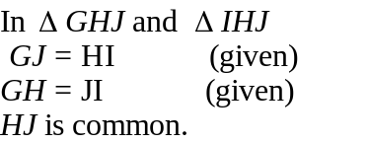
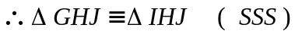
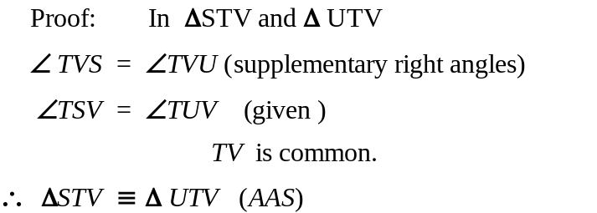(Some students may try to use
RHS as there is sufficient data,
but would need to change given start)
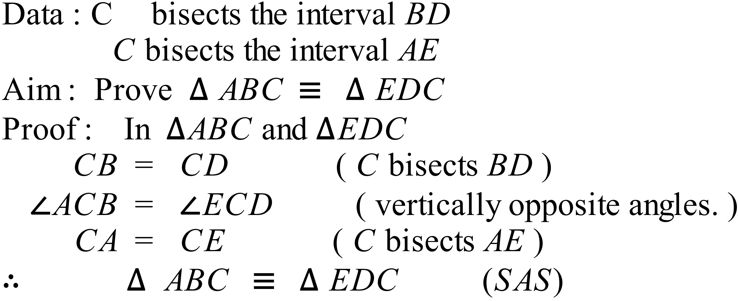

Section 2 (1 mark each)
 | Working | Answers
 | N and S are congruent ( a reflection would transform N to S) | D
 | A translation as there is no change of orientation or sense. | D
 | Figure A is a reflection in a vertical line. | A
 | Figure B is a rotation through 180º. | B
 | Figure C has two sides and an included angles the same as the original. SAS | C
 | Three pairs of corresponding angles only ensures we have similar figures, not congruent figures. | A
 | Triangles X and Z have RHS corresponding. | C
 | Only I and IV are congruent. SSS | B
 | AAS using the vertically opposite angles and the two pieces of given data. | A
 | Only I and II are congruent. SAS | D
 | In D the arrangement gives a SAS arrangement which allows proof. | D
 | The information which is common in both triangles is the sides of 77 cm (hypotenuse) and 62cm and the right angles. So use RHS. | B
 | Since all sides are equal we have UV = WV and UX = WX and XV in common.  Can use SSS. | D
 | 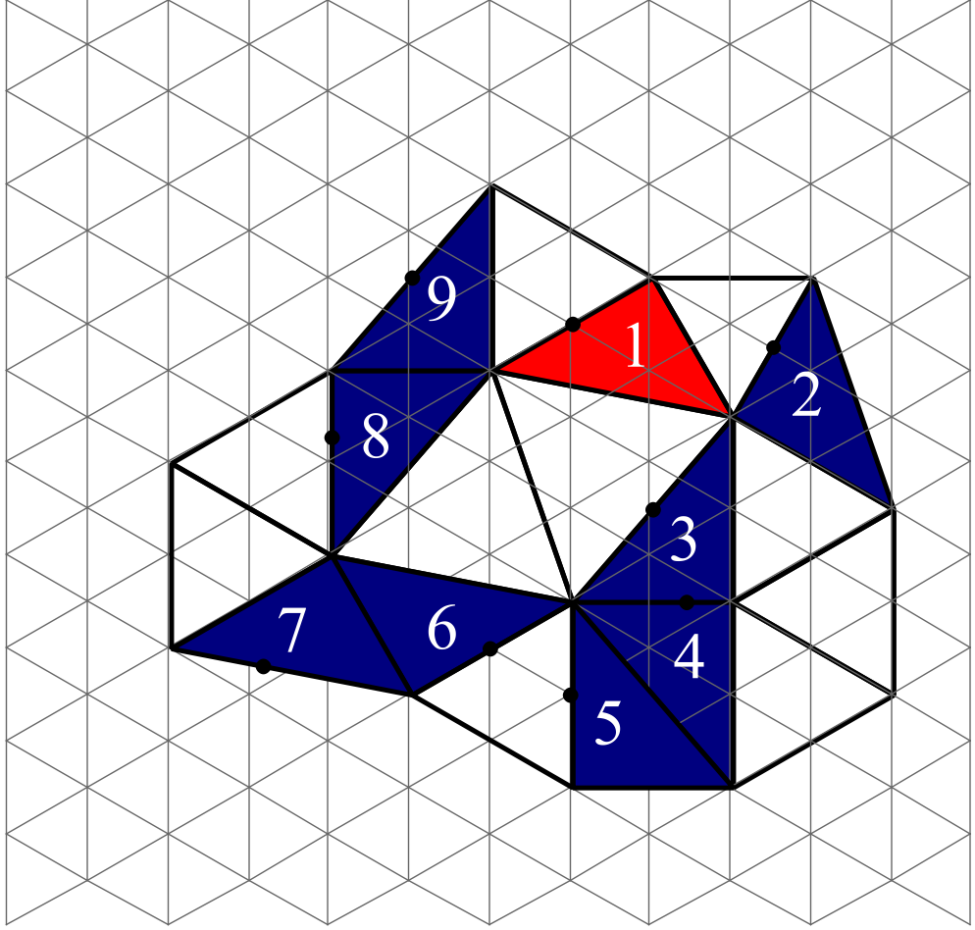 | C
 | Alternate angles on parallel lines. | A

Section 3
 | Working and Answers | Marks
1. | 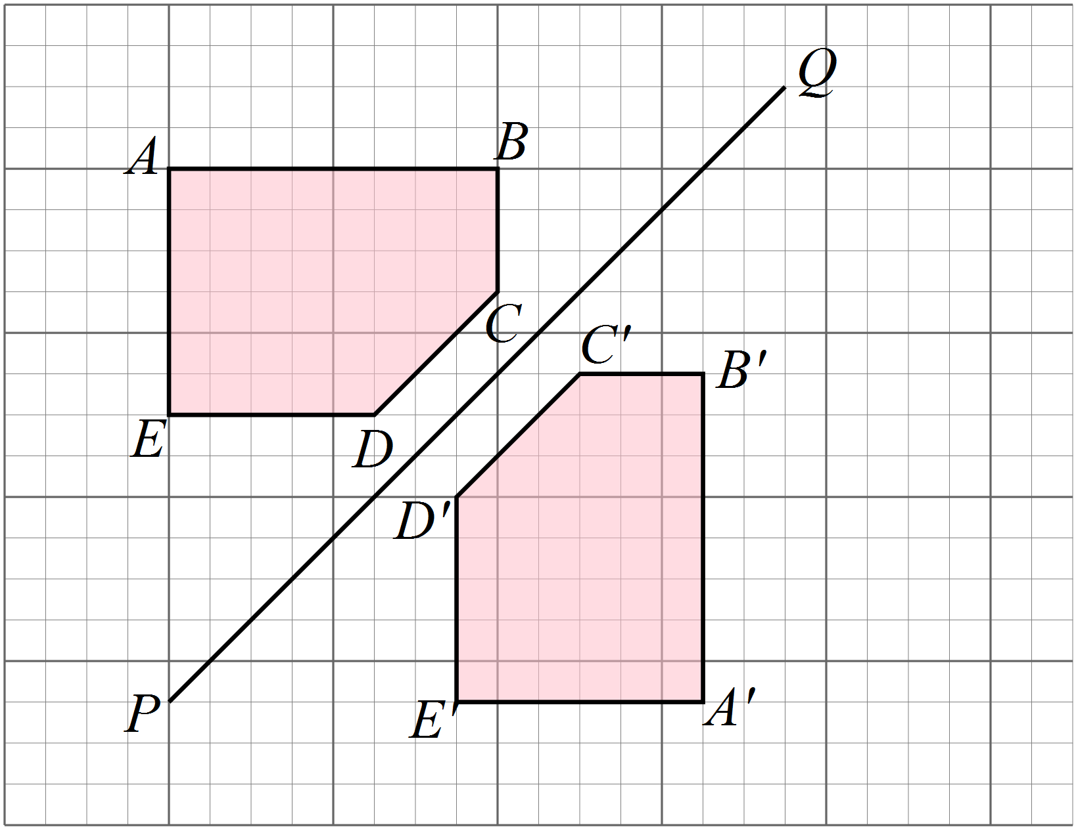a) | 2 marks for correct image, labelled.  1 mark if incomplete, incorrect or confused, but with some idea of correct method.
 | b) Both are approximately 13 mm in length, ie equal in length. | 1 mark
 | c) CONGRUENT, but accept ½ mark for same shape or same size or words to that effect. | 1 mark
2. | At least five extra shapes added to the pattern, eg below.  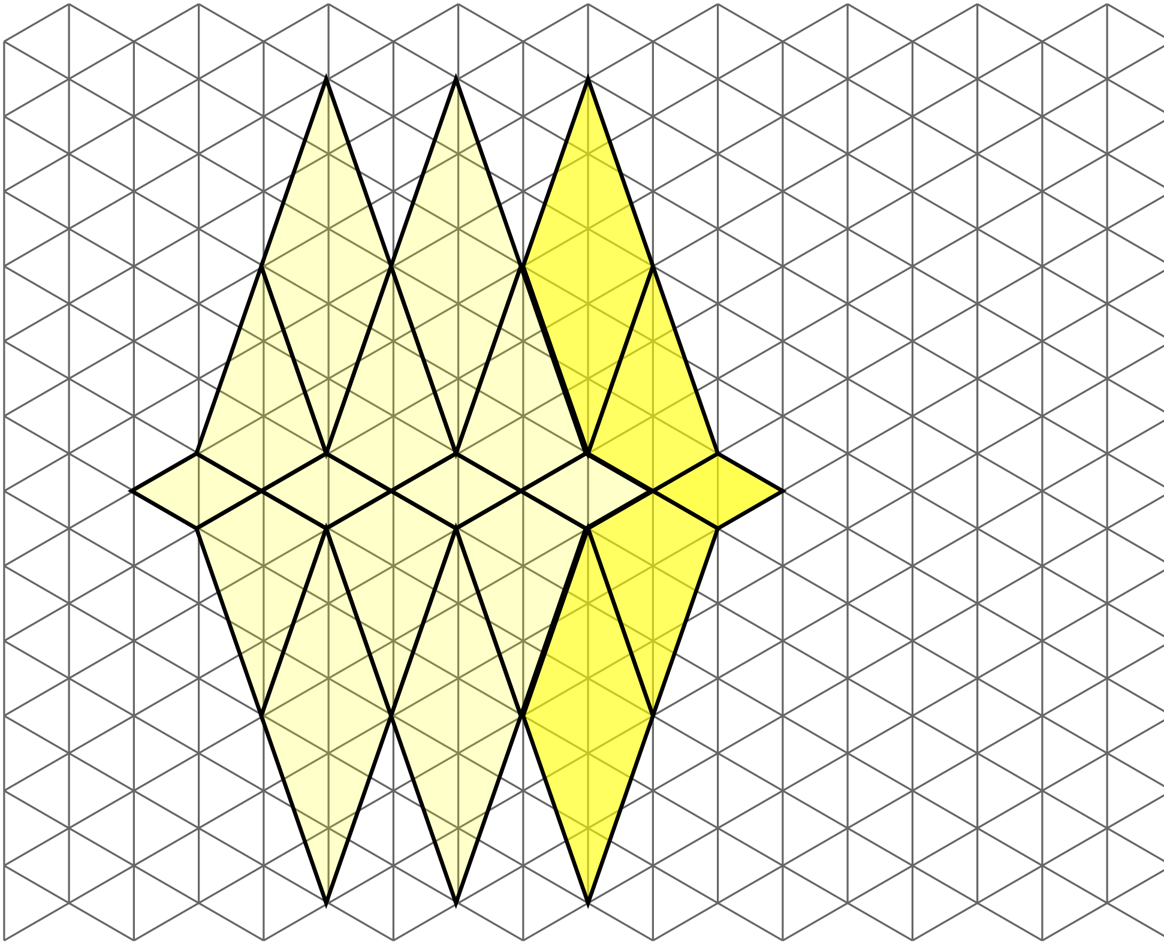 | 2 marks for correct pattern with at least 5 shapes.  1 mark if incomplete, incorrect or confused, but with some idea of correct method.
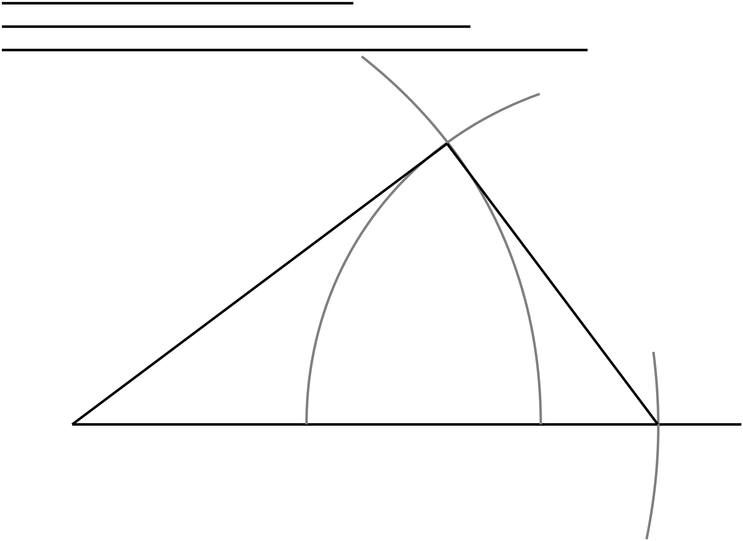3. | (a)  Use instruments to accurately draw a triangle congruent to ABC. | 2 marks for correct triangle, with construction lines.  1 mark if incomplete, incorrect or confused, but with some idea of correct method.
 | (b) A triangle PQR has two sides which measure 6 cm and 8 cm, with an angle of 30º between them.  Use instruments to accurately draw a triangle congruent to PQR.  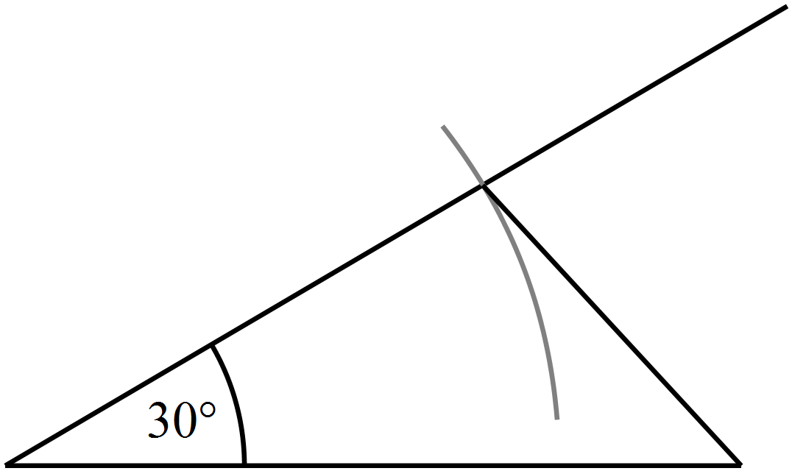 | 2 marks for correct triangle, with construction lines.  1 mark if incomplete, incorrect or confused, but with some idea of correct method.
4. | (a) Prove that  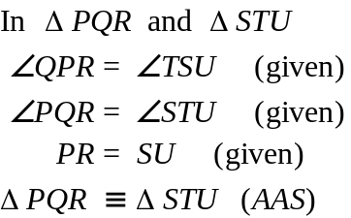 | 2 marks for complete and correct proof.  1 mark for partially complete proof or one with a minor error.
 | (b) Prove that  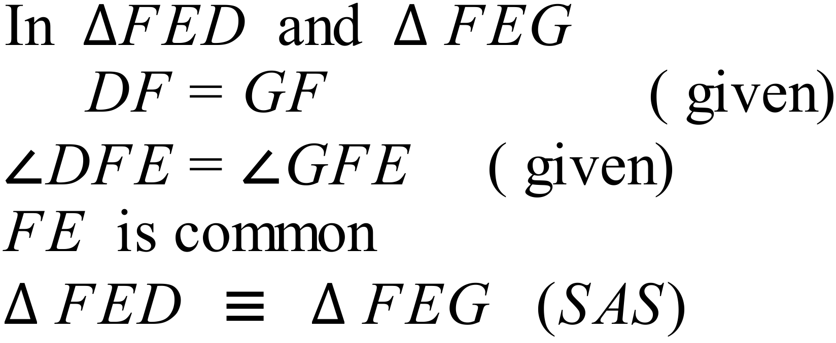 | 2 marks for complete and correct proof.  1 mark for partially complete proof or one with a minor error.
 | (c) In the quadrilateral VWXY, VW || YX and VY || WX.  Prove that  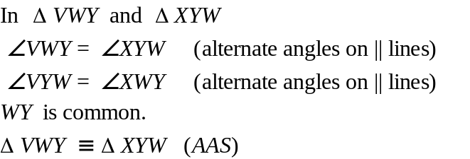 | 2 marks for complete and correct proof.  1 mark for partially complete proof or one with a minor error.

Multiple Choice Answer Sheet
Name Marking Sheet
Completely fill the response oval representing the most correct answer.

1. A B C D
2. A B C D
3. A B C D
4. A B C D
5. A B C D
6. A B C D
7. A B C D
8. A B C D
9. A B C D
10. A B C D
11. A B C D
12. A B C D
13. A B C D
14. A B C D
15. A B C D

